**Report**

Of

**Summer ‘20 Training Project** at

**MentorrBuddy**

on

***Covid-19 Data Analysis***

Submitted

In the Partial Fulfillment of

Bachelor of Technology

**Submitted by:                                                         Submitted to:**

Yerra Hari Baba                                               Mr. Sachin Lohar

Vaishnavi BaluReddy

Ameerishetty Akhila

**Table of Contents**

|  |  |
| --- | --- |
| **Content** | **Page Number** |
| Abstract | *2* |
| Summary of figures and graphs | *3* |
| Part 1: Importing Libraries | *7* |
| Part 2: Including Dataset | *9* |
| Part 3: Data Cleaning and Refining | *13* |
| Part 5: Data Visualization | *21* |
| Part 6: Data Splitting and Data Modelling | *39* |
| Part 7: Conclusion | *55* |

**ABSTRACT:**

WHO declared COVID-19 as a Public Health Emergency of International Concern (PHEIC) on 30 January 2020.The outbreak of COVID-19 in different parts of the world is a major concern for all the administrative units of respective countries.

India is also facing this very tough task for controlling the virus outbreak and has managed its growth rate through some strict measures. This study presents the current situation of coronavirus spread in India.

In the wake of the Coronavirus outbreak, many data sources have been made available to the public in an effort to encourage research in the field. The goal is to apply recent advances in machine learning and natural language processing to generate insights into the infectious disease. As it is true of most text mining efforts, generating summary statistics and visually representing the content of text information is a very important part of exploratory data analysis.

In this project, we will perform exploratory data analysis on the COVID-19 cases in India. We will use python libraries such as ‘seaborn’, ‘matplotlib’ ,'Folium'and Pandas to explore and visualize the categorical and text information provided in the data set.

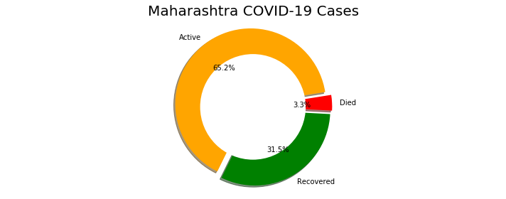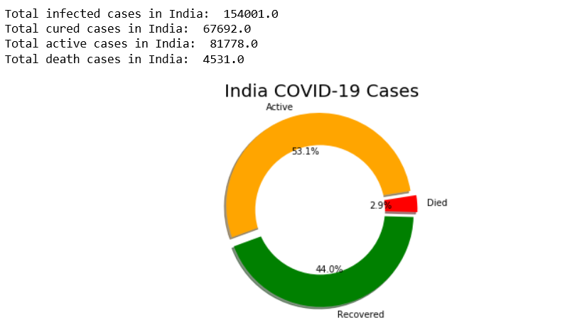**Summary of Figures and Charts**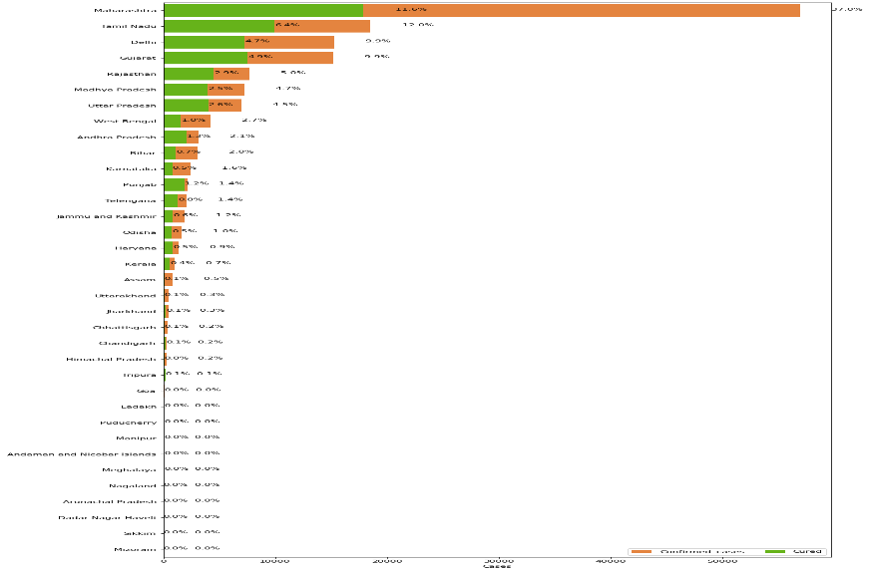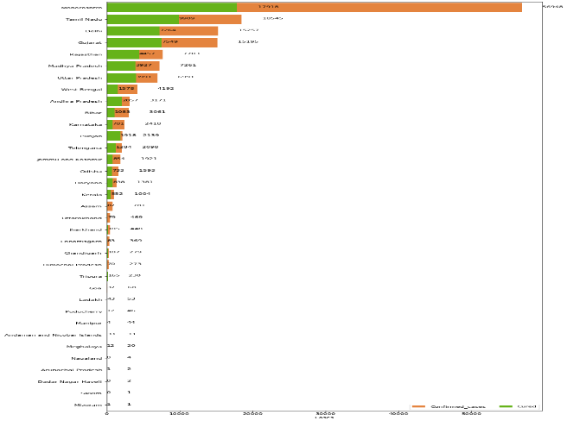

**Overall Covid-19 Status in India**

**Statewise Covid-19 Status: 35 Pie charts**

**Statewise Covid-19 Cases in Percentage: Column chart**

**Statewise Covid-19 Cases in Number: Column chart**

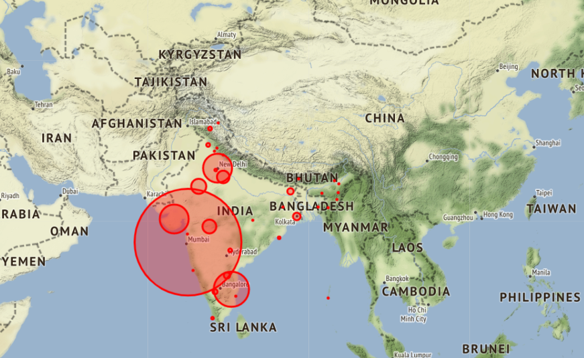

**Concentration of confirmed cases in India on a Statementerrain map.**

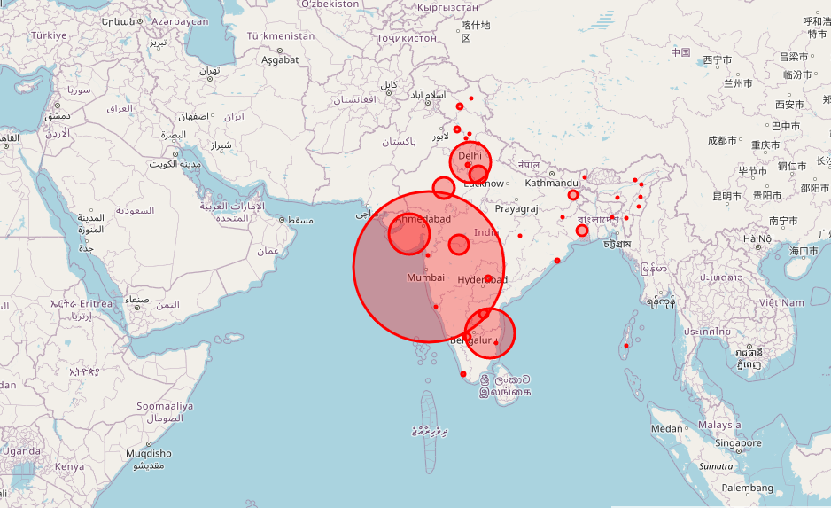

**Concentration of confirmed cases in India on a OpenStreetMap.**

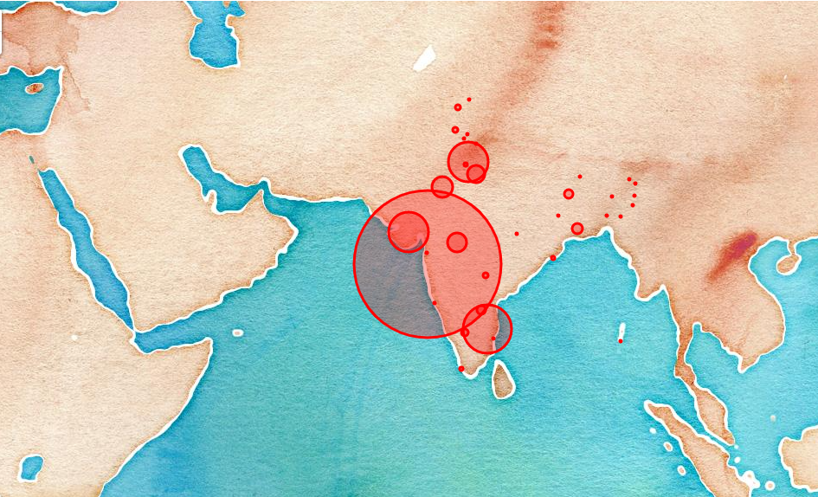

**Concentration of confirmed cases in India on a OpenStreetMap.**

**Coronavirus Cases in India on**

**daily basis**

**Trend of Coronavirus Cases in India**

**(Cumulative cases)**

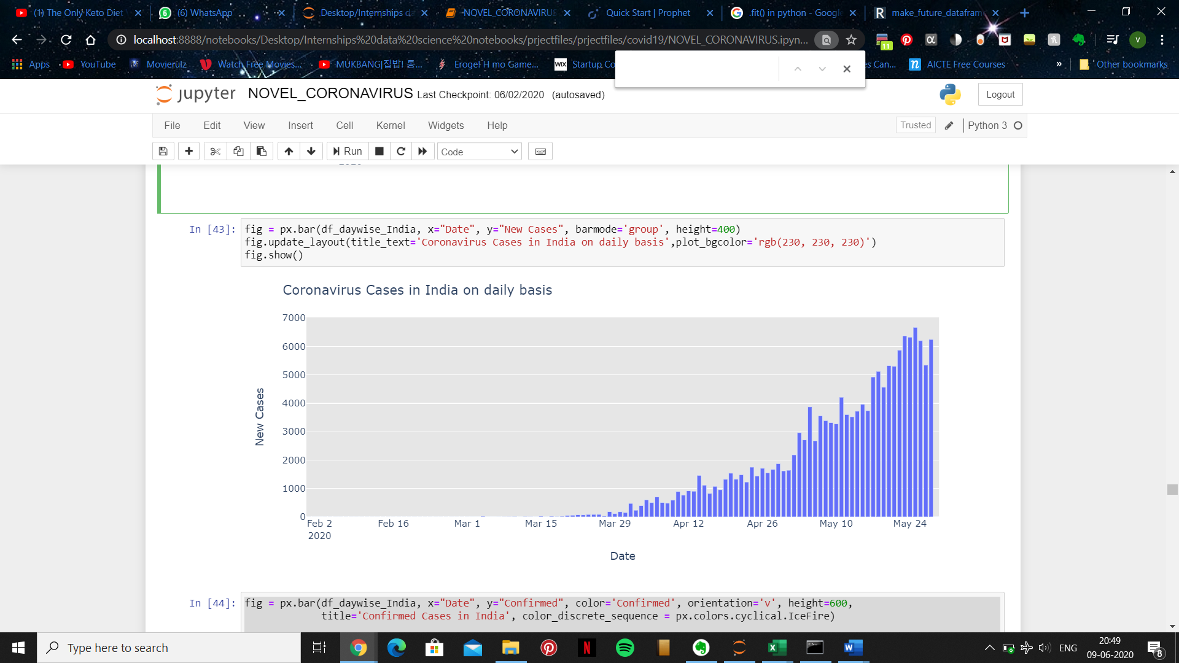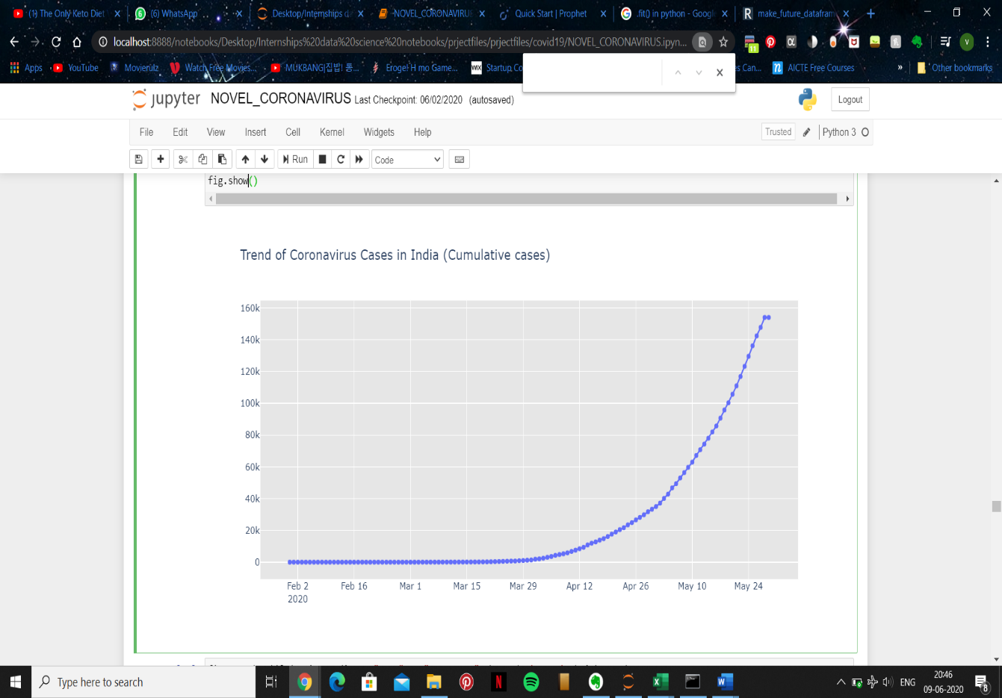

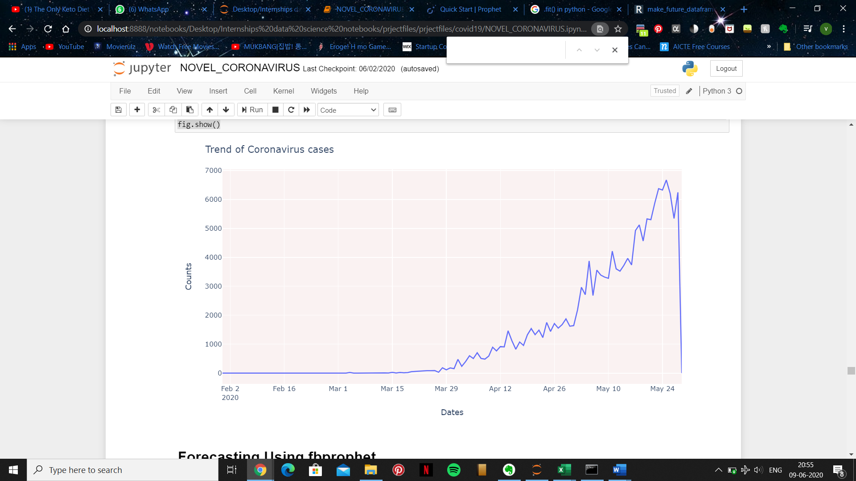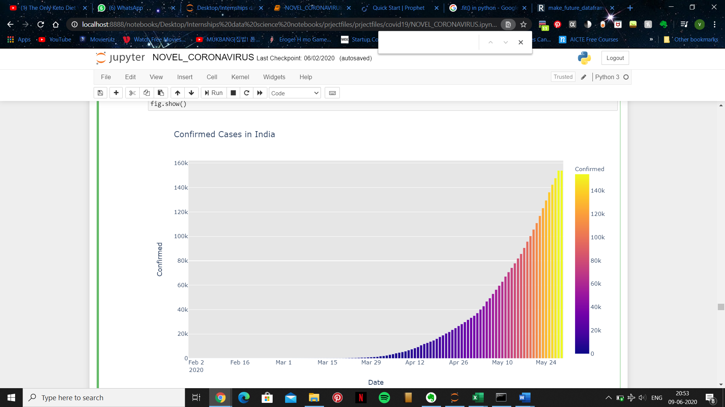

**Trend of Coronavirus cases**

**Confirmed Cases in India**

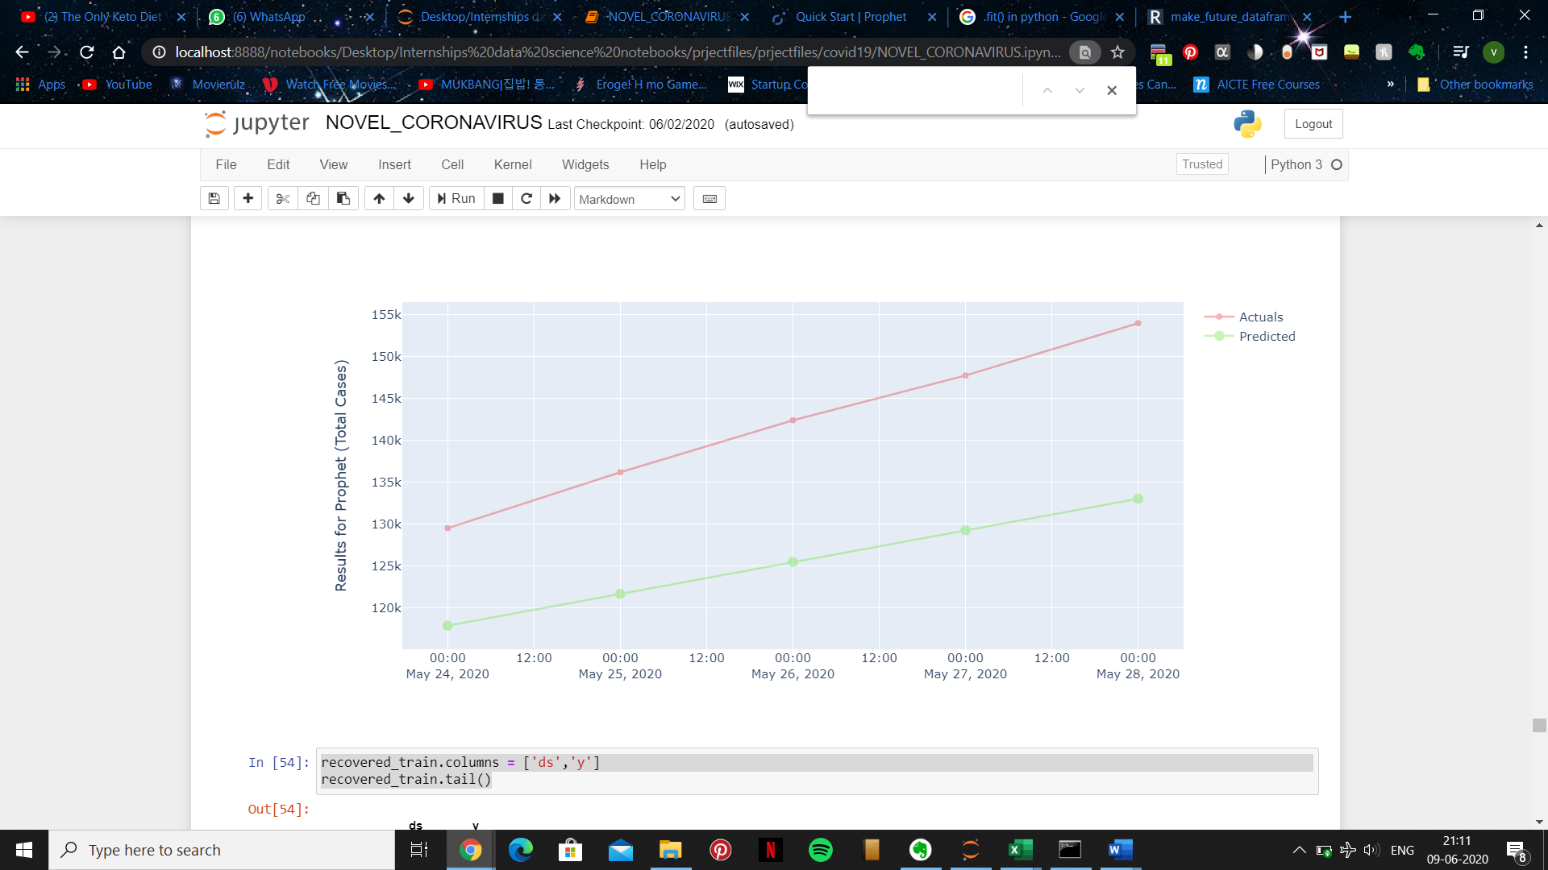**Results for Prophet (Total Cases)**

**Results for Prophet (Recovered)**

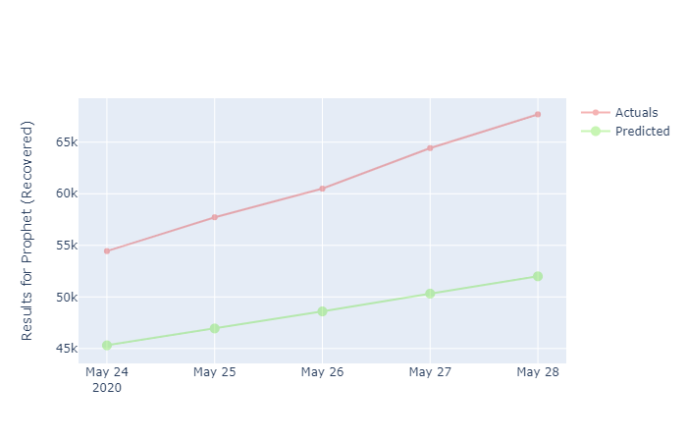

**Results for Prophet (Death)**

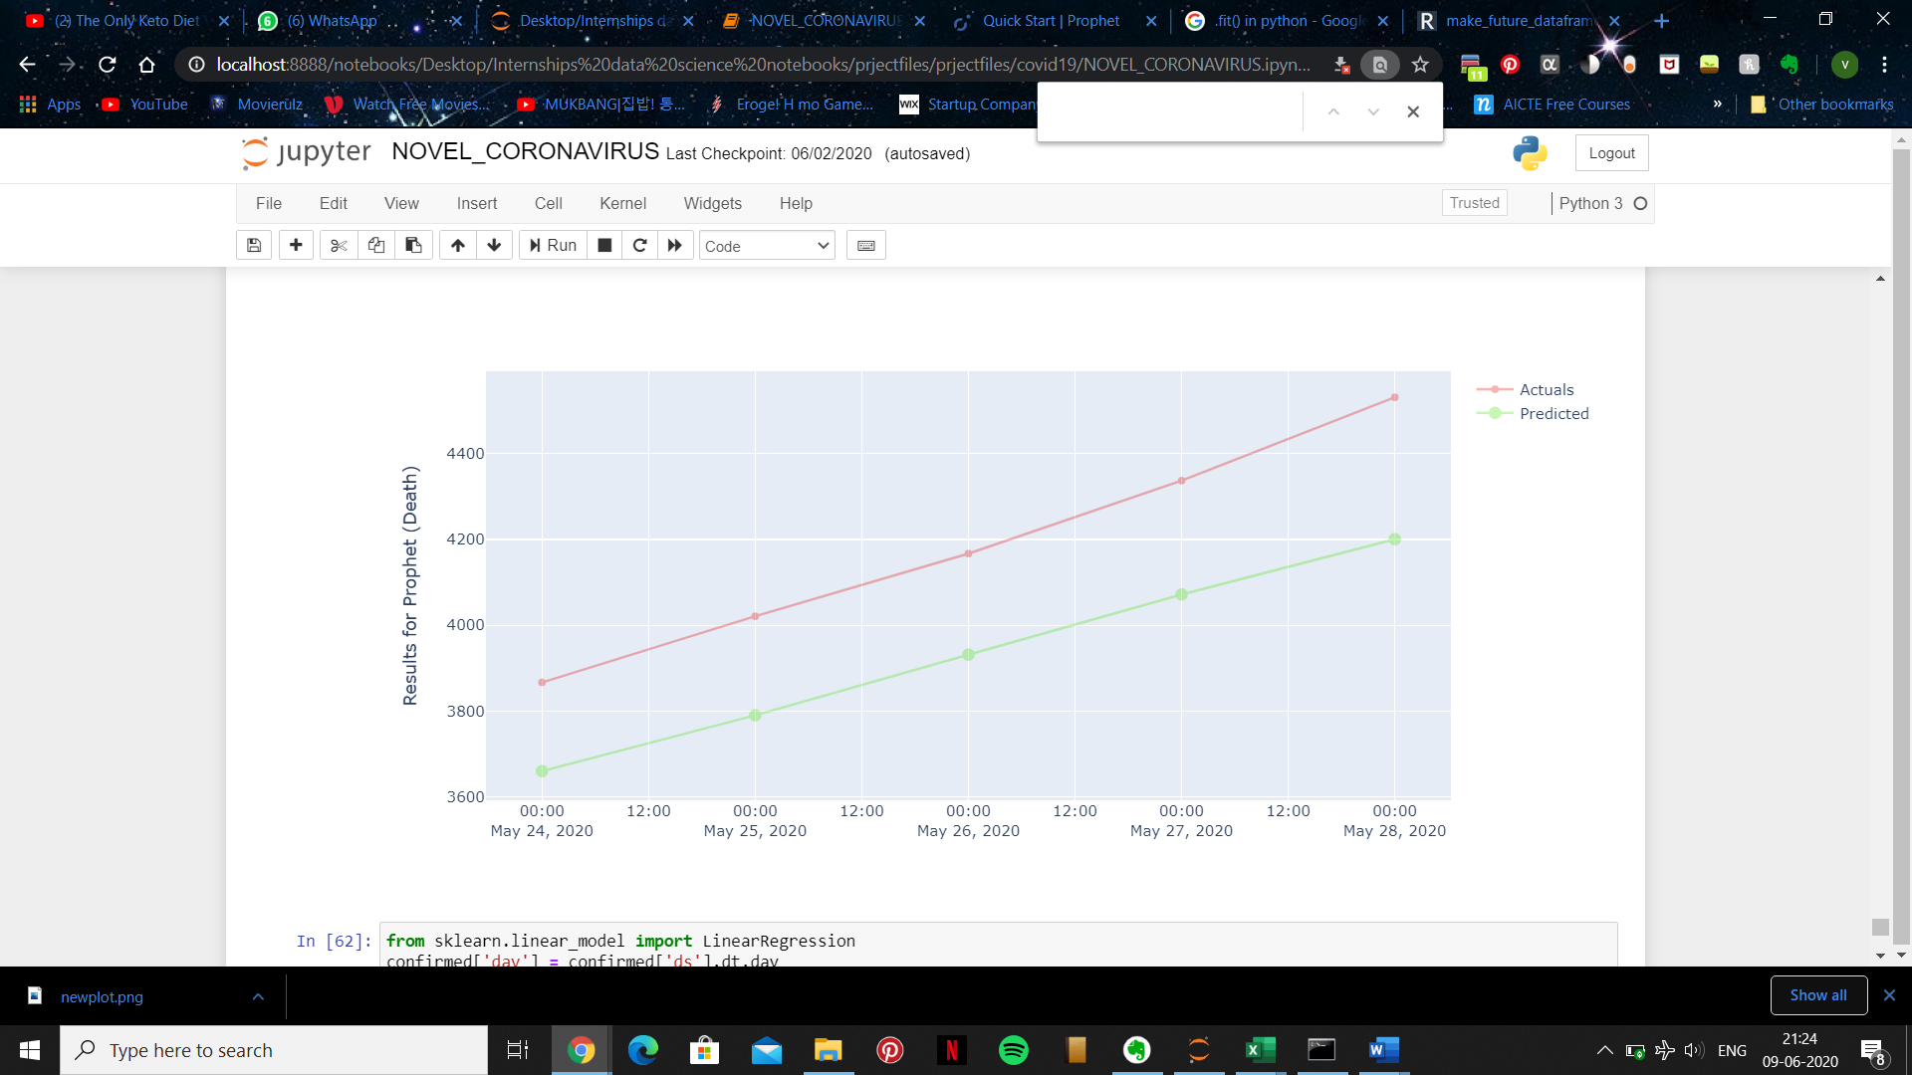

**Part 1: Importing Libraries**

The first and foremost step we do is to import packages. Here we used the following packages.

These packages help us do all the required and desired operations on the data to get meaningful and concise results that we can draw some conclusion from.

* **pandas -**

Pandas is a software library written for the Python programming language for data manipulation and analysis.

* **numpy -**

NumPy is a python library used for working with arrays. NumPy stands for Numerical Python.

* **matplotlib.pyplot -**

matplotlib. pyplot is a collection of command style functions that make matplotlib work like MATLAB. Each pyplot function makes some change to a figure: e.g., creates a figure, creates a plotting area in a figure, plots some lines in a plotting area, decorates the plot with labels, etc.

* **Seaborn -**

Seaborn is a Python data visualization library based on matplotlib. It provides a high-level interface for drawing attractive and informative statistical graphics.

* **plotly -**

Plotly allows users to import, copy and paste, or stream data to be analyzed and visualized. For analysis and styling graphs, Plotly offers a Python sandbox (NumPy supported), datagrid, and GUI.

* **folium -**

Folium is a powerful Python library that helps you create several types of Leaflet maps.

* **rcParams - I**t is said that matplotlibrc configuration files are used to customize all kinds of properties in matplotlib , that one can dynamically change the default rc settings to customize the default parameters for example through:

matplotlib.rcParams['font.family'] = 'times new roman'

* **warnings -**

Warnings are provided to warn the developer of situations that aren’t necessarily exceptions. A warning in a program is distinct from an error. Python program terminates immediately if an error occurs. Conversely, a warning is not critical. It shows some message, but the program runs. The warn() function defined in the ‘warning‘ module is used to show warning messages.

* **sklearn.metrics -**

The sklearn. metrics module implements several loss, score, and utility functions to measure classification performance.

* **mean_squared_error -**

The mean square error is the average of the square of the difference between the observed and predicted values of a variable. In Python, the MSE can be calculated rather easily, especially with the use of lists.

* **warnings.filterwarnings -**

By default, Python installs several warning filters, which can be overridden by the -W command-line option, the PYTHONWARNINGS environment variable and calls to filterwarnings() .

* **%matplotlib inline -**

%matplotlib inline sets the backend of matplotlib to the 'inline' backend: With this backend, the output of plotting commands is displayed inline within frontends like the Jupyter notebook, directly below the code cell that produced it.

**Part 2: Importing Dataset**

**1:**

* The Libraries are the executed to be used throughout the program.

import pandas as pd

import numpy as np

import matplotlib.pyplot as plt

import seaborn as sns

import plotly

import plotly.express as px

import plotly.graph_objects as go

import folium

from folium import plugins

plt.rcParams['figure.figsize'] = 10, 12

import warnings

from sklearn.metrics import mean_squared_error

warnings.filterwarnings('ignore')

%matplotlib inline

**2:**

* Importing the to be analysed into Data Frames.
* **DataFrames** allow you to store and manipulate tabular data in rows of observations and columns of variables.

df_India = pd.read_csv('covid_19_India.csv')

India_coord = pd.read_excel('Indian Coordinates.xlsx')

**3:**

* The below **dataframe.info()** function is used to get a concise summary of the dataframe. It is useful when we do exploratory analysis of the data and get a quick review.

print(df_India.info())

**Output:**

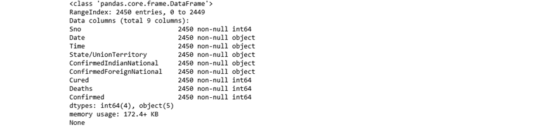

* Pandas **head()** and **tail()** methods are used to give top and bottom 5 rows by default respectively

**4:**

df_India.head()

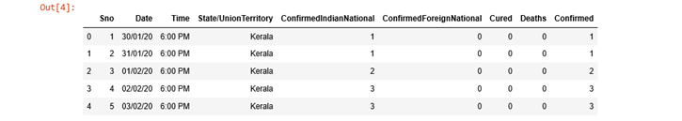**Output:**

**5:**

df_India.tail()

**Output:**

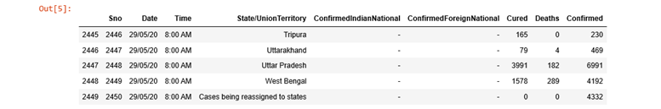

* A **datatype** object (an instance of **numpy. dtype** class) describes how the bytes in the fixed-size block of memory corresponding to an array item should be interpreted. It describes the following aspects of the data: Type of the data (integer, float, Python object, etc.)**6:**

df_India.dtypes

**Output:**

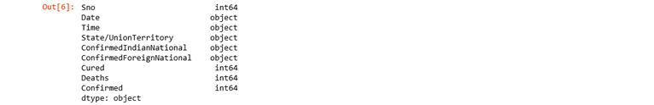

**7:**

print(India_coord.info())

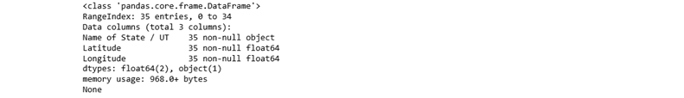**Output:**

**8:**

India_coord.head()

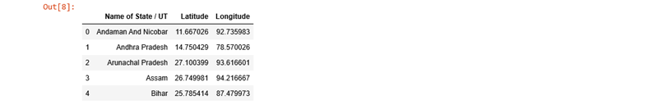**Output:**

**Part 3: Data Cleaning and Refining**

Data cleansing is important because it improves your data quality and in doing so, increases overall productivity. When you clean your data, all outdated or incorrect information is gone – leaving you with the highest quality information.

**9:**

* In the below code, we are replacing '-' with zeros and the we are dropping a column named 'S.No'. axis= 1 represents column and inplace = True helps in permanent deletion of required attribute.
* Pandas **to_datetime()** method helps to convert string Date time into Python Date time object.
* Pandas **sort_values()** function sorts a data frame in Ascending or Descending order of passed Column. It’s different than the sorted Python function since it cannot sort a data frame and particular column cannot be selected.

def replace_dash_with_zeros(inp):

return int(inp.replace("-","0"))

df_India.drop(['Sno'],axis=1,inplace=True)

df_India['Date'] = pd.to_datetime(df_India['Date'], format = "%d/%m/%y")

# https://www.stat.berkeley.edu/~s133/dates.html

df_India['ConfirmedIndianNational'] = df_India['ConfirmedIndianNational'].apply(replace_dash_with_zeros)

df_India['ConfirmedForeignNational'] = df_India['ConfirmedForeignNational'].apply(replace_dash_with_zeros)

df_India.sort_values("Confirmed", ascending = False, inplace = True)

df_India

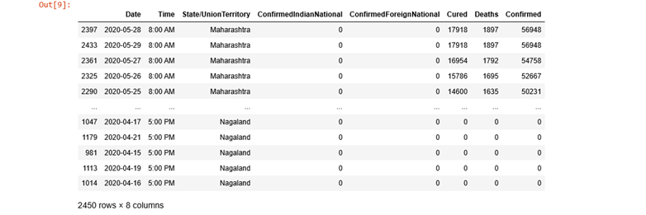**Output:**

**10:**

* The **loc()** function is used to access a group of rows and columns by label(s) or a boolean array. . loc[] is primarily label based, but may also be used with a boolean array. ... A callable function with one argument (the calling Series or DataFrame) and that returns valid output for indexing

df_India.loc[df_India["ConfirmedForeignNational"] == "-",:]

**Output:**



**11:**

* The **zip()** function returns a zip object, which is an iterator of tuples where the first item in each passed iterator is paired together, and then the second item in each passed iterator are paired together etc.
* If the passed iterators have different lengths, the iterator with the least items decides the length of the new iterator.

list(zip(df_India.columns,df_India.dtypes,df_India.isna().sum()))

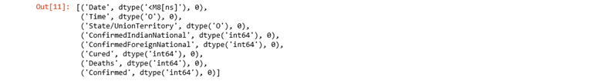**Output:**

**12:**

* **Now we print the data available from the lowest to the highest date.**

print(f'We have data available from : {df_India.Date.min()} to {df_India.Date.max()}')

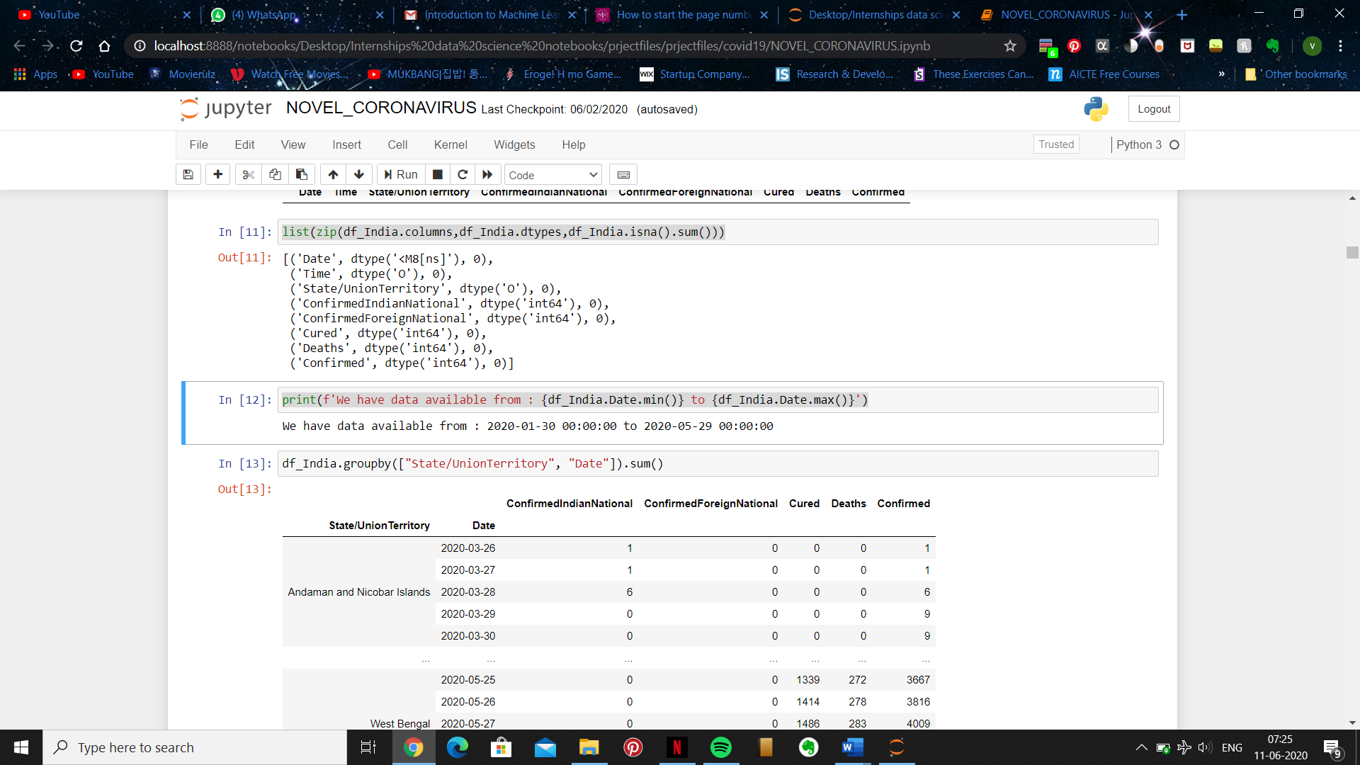**Output:**

**13:**

* Pandas **dataframe.groupby()** function is used to split the data into groups based on some criteria. pandas objects can be split on any of their axes. The abstract definition of grouping is to provide a mapping of labels to group names.
* The **sum()** function returns a number, the sum of all items in an iterable.

df_India.groupby(["State/UnionTerritory", "Date"]).sum()

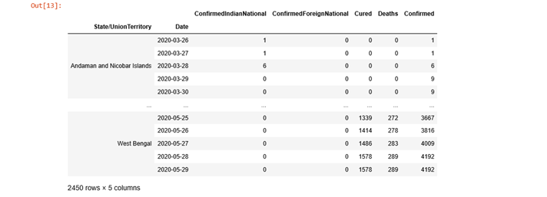**Output:**

**14:**

* **unique()** function. The unique() function is used to find the unique elements of an array. Returns the sorted unique elements of an array. ... the indices of the unique array that reconstruct the input array. the number of times each unique value comes up in the input array.
* **tolist()** function return a list of the values. These are each a scalar type, which is a Python scalar (for str, int, float) or a pandas scalar (for Timestamp/Timedelta/Interval/Period). Example #1: Use Index. tolist() function to convert the index into a list.

States = df_India['State/UnionTerritory'].unique().tolist()

States

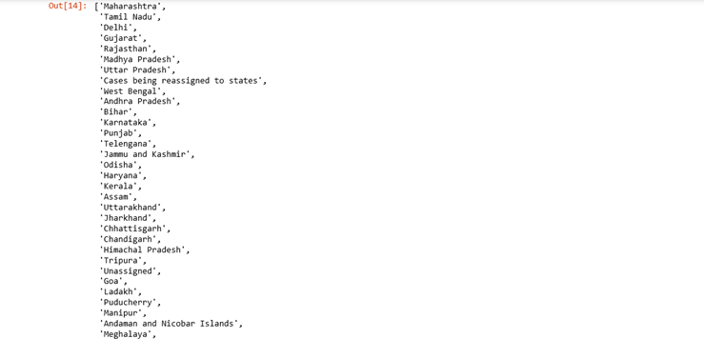**Output:**

**15:**

* **remove()** is an inbuilt function in Python programming language that removes a given object from the list. It does not return any value.

States.remove("Cases being reassigned to states")

States.remove("Unassigned")

States

**Output:**



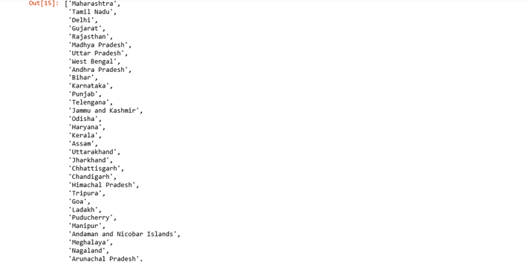

**16:**

* **This gives the length of the dataframe pertaining to the ‘States’**

len(States)

**Output:**

**MERGING DATA FRAMES**

“Merging” two datasets is the process of bringing two datasets together into one, and aligning the rows from each based on common attributes or columns. The words “merge” and “join” are used relatively interchangeably in Pandas and other languages.

**17:**

* **Concat()** is used to concatenate pandas objects along a particular axis with optional set logic along the other axes.

df_final_India = pd.DataFrame()

dates = pd.DataFrame({"Date": pd.date_range(df_India.Date.min(),df_India.Date.max())})

for state in States:

all_dates_df = pd.merge(dates,

df_India.loc[df_India['State/UnionTerritory'] == state,:], on = "Date",

how = "left")

all_dates_df['State/UnionTerritory'] = state

all_dates_df = all_dates_df.fillna(0)

all_dates_df['New Cases'] = all_dates_df['Confirmed'] - all_dates_df['Confirmed'].shift(1)

# print(state)

# display(all_dates_df.loc[all_dates_df['New Cases'] < 0,:])

df_final_India = pd.concat([df_final_India, all_dates_df],axis = 0)

print("Finally we have a data of Size: ",df_final_India.shape)

df_final_India.head()

**Output:**

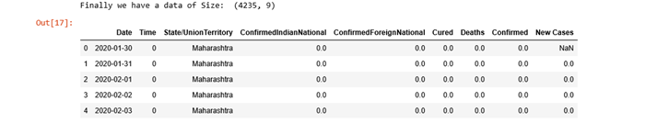

**18:**

* The **dropna()** function is used to remove missing values. **shape** is a tuple that gives you an indication of the number of dimensions in the array.

df_final_India.dropna(inplace = True)

df_final_India.shape

**Output:**

**19:**

* **del** command is used to delete a particular attribute in the data

del df_final_India['Time']

del df_final_India['ConfirmedIndianNational']

del df_final_India['ConfirmedForeignNational']

**20:**

df_final_India

**Output:**

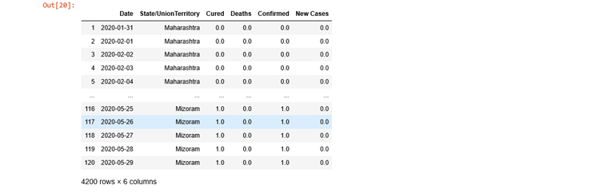

**21:**

* The groupby() function in python allows us to group the data into required parts and allows us to perform required action on the grouped data.

df_final_India.groupby(["State/UnionTerritory", "Date"]).sum()

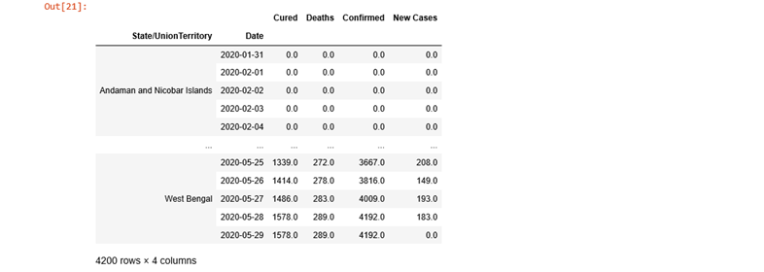**Output:**

**22:**

* Pandas **reset_index()** is a method to reset index of a Data Frame. reset_index() method sets a list of integer ranging from 0 to length of data as index

df_final_India = df_final_India.groupby(["State/UnionTerritory", "Date"]).sum().reset_index()

df_final_India

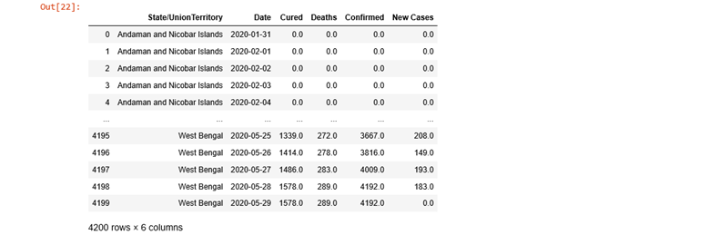**Output:**

**Part 4: Data Visualization**

Data visualization is the act of taking information (data) and placing it into a visual context, such as a map or graph. Data visualizations make big and small data easier for the human brain to understand, and visualization also makes it easier to **detect patterns, trends, and outliers in groups of data**.

**Statewise Covid19 Status in India:**

* Here, matplotlib plt.pie() function help to plot pie chart of given numeric data with labels. It also supports different parameters which help to show better. Importing Library.
* Pie charts are good to show proportional data of different categories and figures are usually in percentages here.
* Here **label**s is asequence of strings providing the labels for each wedge.
* **Colors** is a sequence of matplotlib color args through which the pie chart will cycle. If *None*, will use the colors in the currently active cycle.
* **Explode** is a function which is used to transform each element of a list like to a row, replicating the index values.
* **append()** method appends a passed *obj* into the existing list.
* We then create a function called **create_circle().**
* In this function, we create a variable called circle and set it equal to **plt.Circle**((0,0), gives the circle a center of (0,0) on a axis 0.
* The line, **plt.axis**('scaled'), gives appropriate scaling that you specify for the shape.
* A **DataFrame()** is a two-dimensional data structure, i.e., data is aligned in a tabular fashion in rows and columns

def plot_pie(active,cured,death,title):

labels = ['Active','Recovered','Died']

sizes = [active,cured,death]

color= ['#66b3ff','green','red']

explode = []

for i in labels:

explode.append(0.05)

plt.figure(figsize= (15,6))

plt.pie(sizes, labels=labels, autopct='%1.1f%%', startangle=9, explode =explode,colors =

color)

centre_circle = plt.Circle((0,0),0.70,fc='white')

fig = plt.gcf()

fig.gca().add_artist(centre_circle)

plt.title(title + 'COVID-19 Cases',fontsize = 20)

plt.axis('equal')

plt.tight_layout()

**24:**

* In the below code we have defined plot_pie function which is used to plot the graphs or charts to represent our data frame visually, here we are representing state wise cases date intp pie chart for that we are giving labels {‘Active’,’Recovered’,’died’} this three labels are represented with different colors in the pie chart**.**

total_cases_india = 0

cured_cases_india = 0

death_cases_india = 0

active_cases_india = 0

state_df = pd.DataFrame()

for state in States:

one_state_df = df_final_India.loc[df_final_India['State/UnionTerritory'] == state,:]

state_df = pd.concat([state_df,pd.DataFrame(one_state_df.iloc[-1,:]).T],axis = 0)

total_cases = one_state_df['Confirmed'].values[-1]

cured = one_state_df['Cured'].values[-1]

deaths = one_state_df['Deaths'].values[-1]

active = total_cases - cured - deaths

plot_pie(active, cured, deaths,state)

total_cases_india += total_cases

cured_cases_india += cured

death_cases_india += deaths

active_cases_india += active

**Output:**

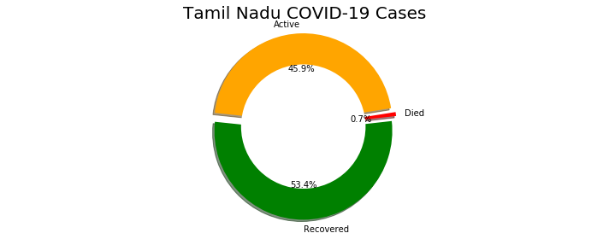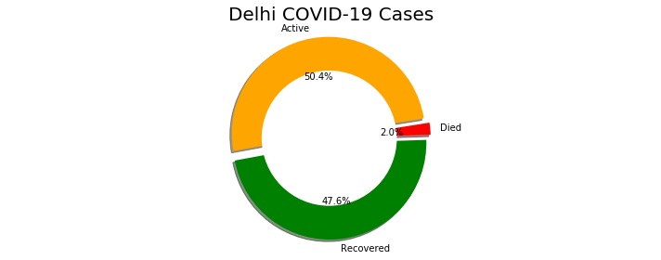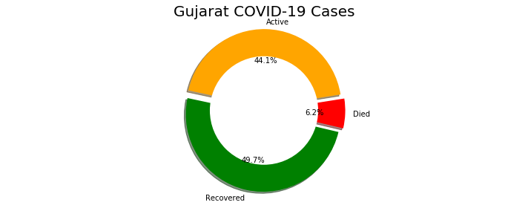

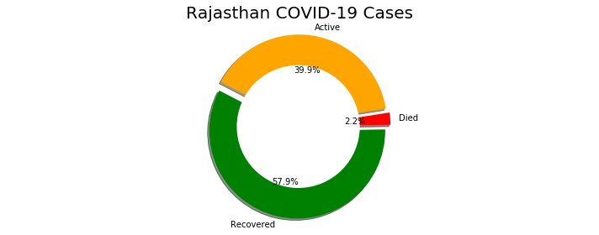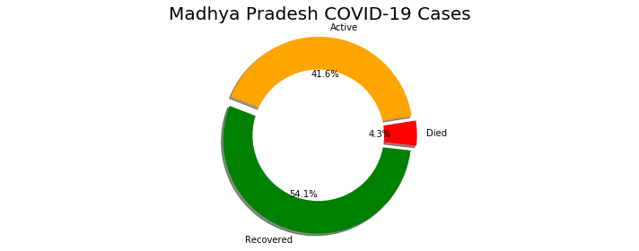 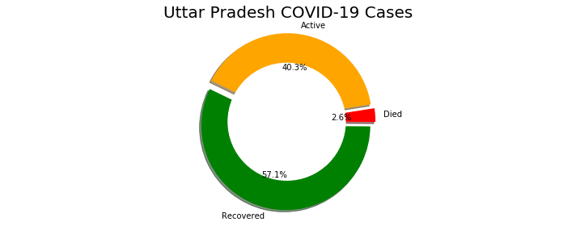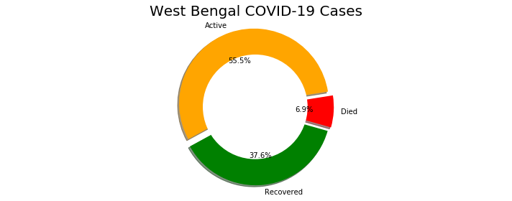

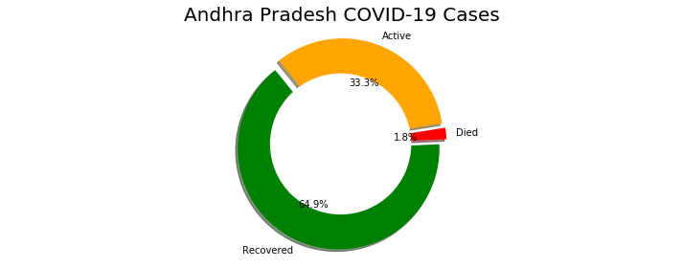 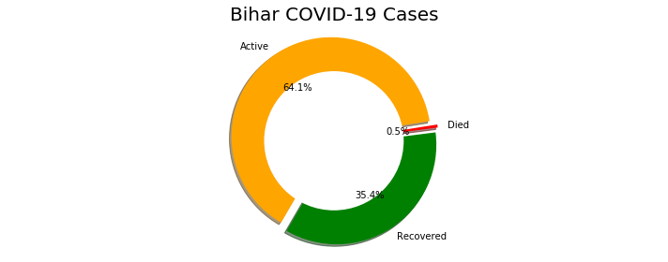 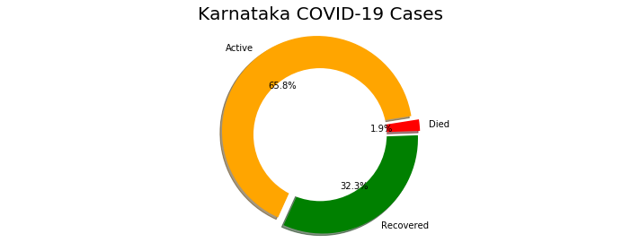 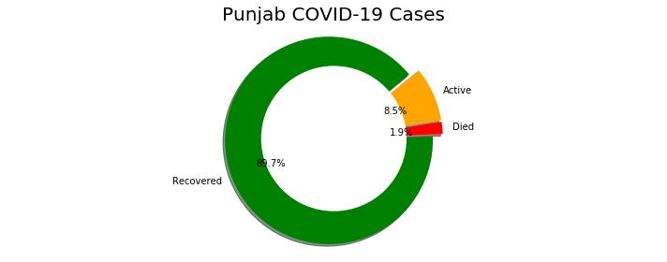

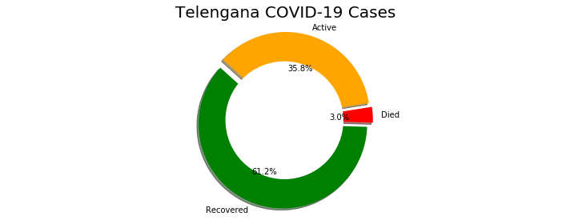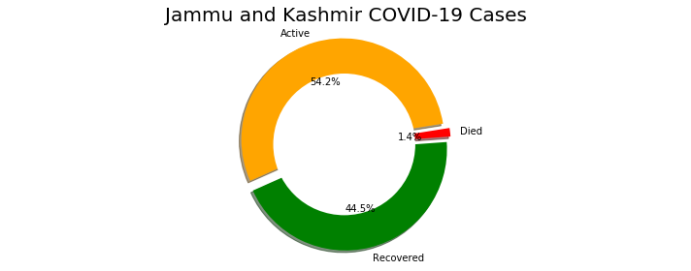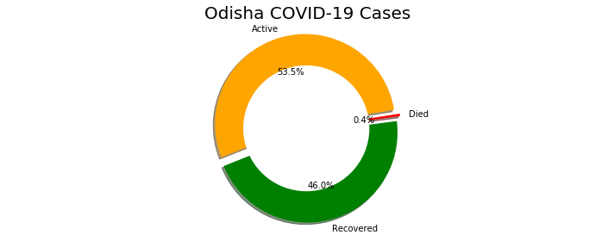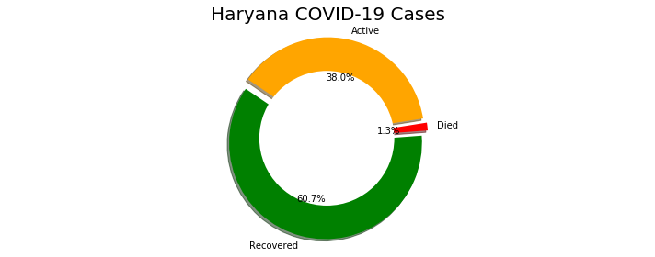

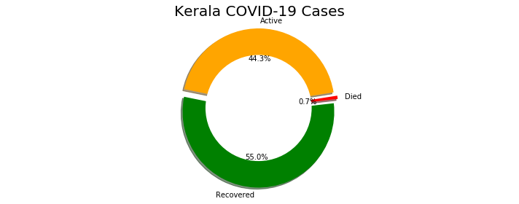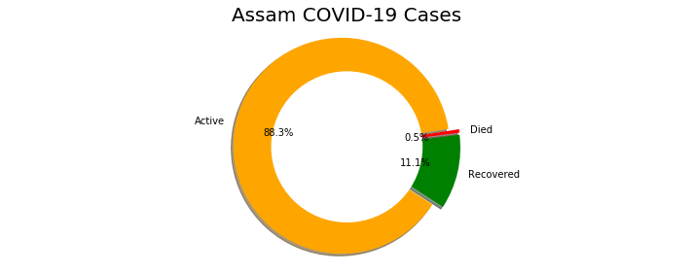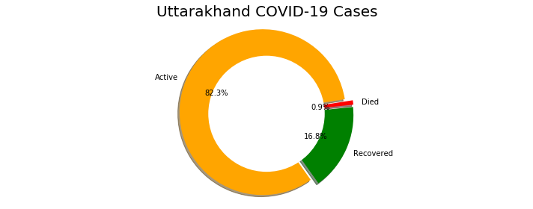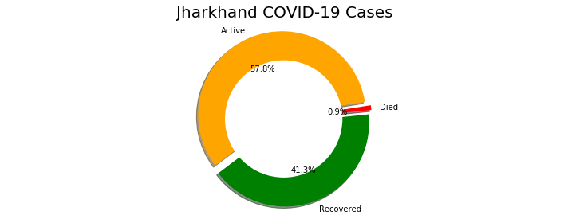

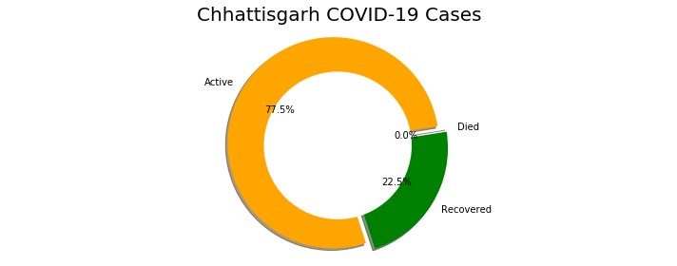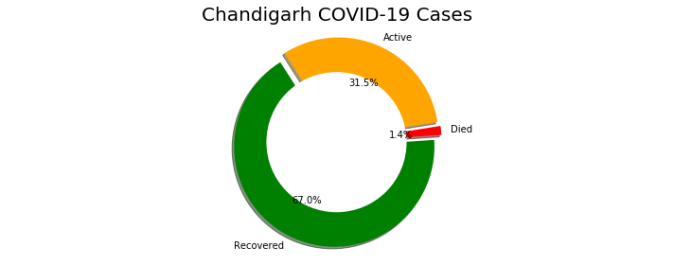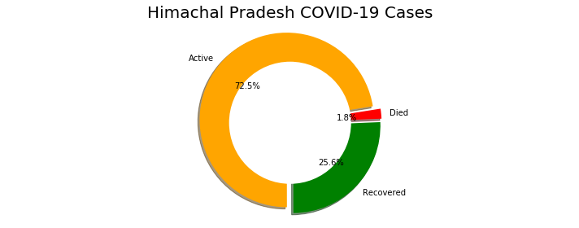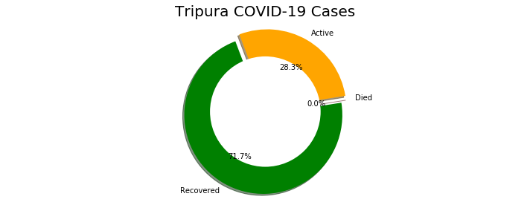

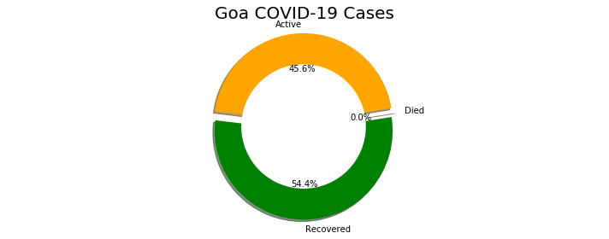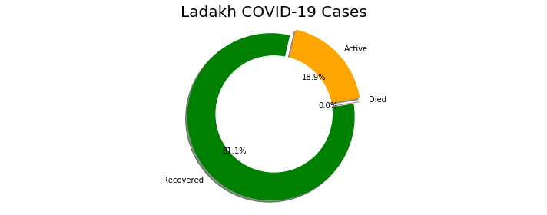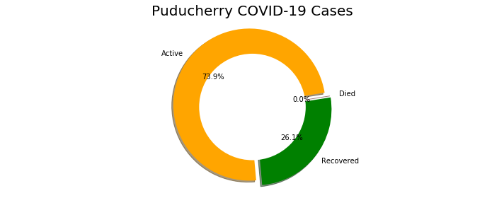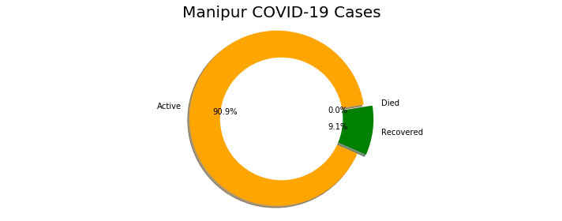

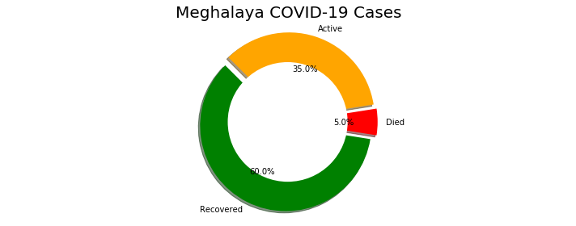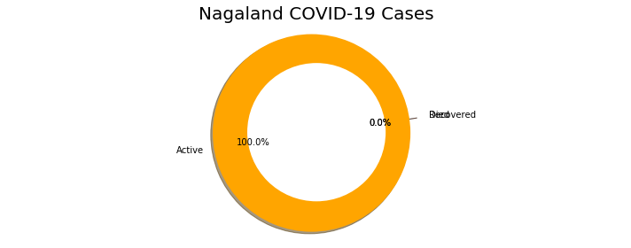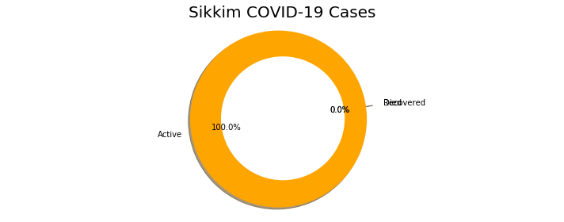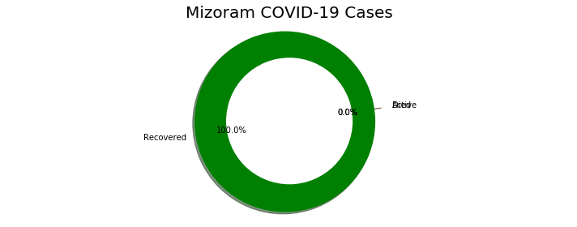

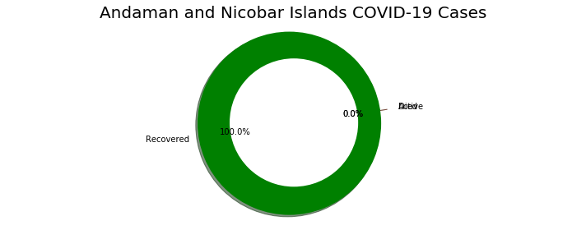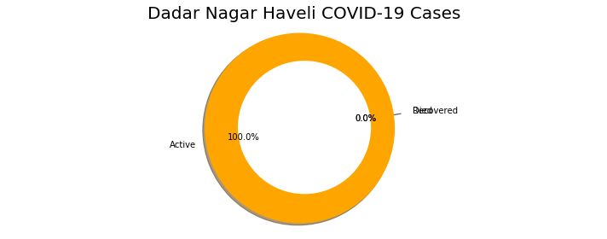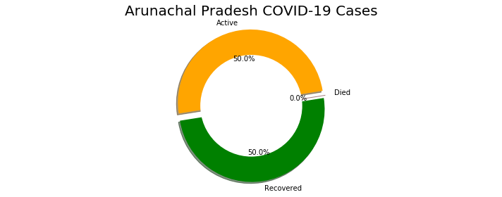

**25:**

* Pandas has a built-in **reset_index ()** function. So to reset the index to the default integer index beginning at 0, you can simply use the built-in reset_index () function. This will make the integer index the default index and take the existing index and make it a column

state_df.reset_index(inplace = True,drop = True)

state_df

**Output:**

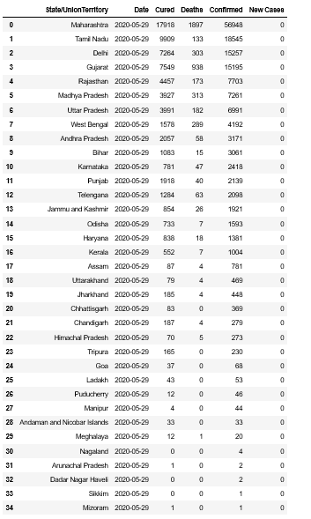

The Matplotlib **subplot()** function can be called to plot two or more plots in one figure. Matplotlib supports all kind of subplots including 2x1 vertical, 2x1 horizontal or a 2x2 grid.

* A **barplot()** method is one of the most common type of plot. It shows the relationship between a numerical variable and a categorical variable.
* Here legend is an area describing the elements of the graph. In the matplotlib library, there’s a function called **legend()** which is used to place legend on axis.
* The **annotate() function** in pyplot module of matplotlib library is used to annotate the point xy with text s.

**26:**

f, ax = plt.subplots(figsize=(12, 28))

data = state_df[['State/UnionTerritory','Confirmed','Cured','Deaths']]

data.sort_values('Confirmed',ascending=False,inplace=True)

sns.set_color_codes("pastel")

sns.barplot(x="Confirmed", y="State/UnionTerritory", data=data,label="Total", color="red")

sns.set_color_codes("muted")

sns.barplot(x="Cured", y="State/UnionTerritory", data=data, label="Cured", color="green")

ax.legend(ncol=5, loc="lower right", frameon=True)

ax.set(ylabel="",xlabel="Cases")

i = 0

for p in ax.patches:

x = p.get_x() + p.get_width() + 3

y = p.get_y() + p.get_height()/2

if i <= len(States):

ax.annotate(" "*10 + str(int(p.get_width())), (x, y))

else:

ax.annotate(int(p.get_width()), (x, y))

i += 1

**Output:**

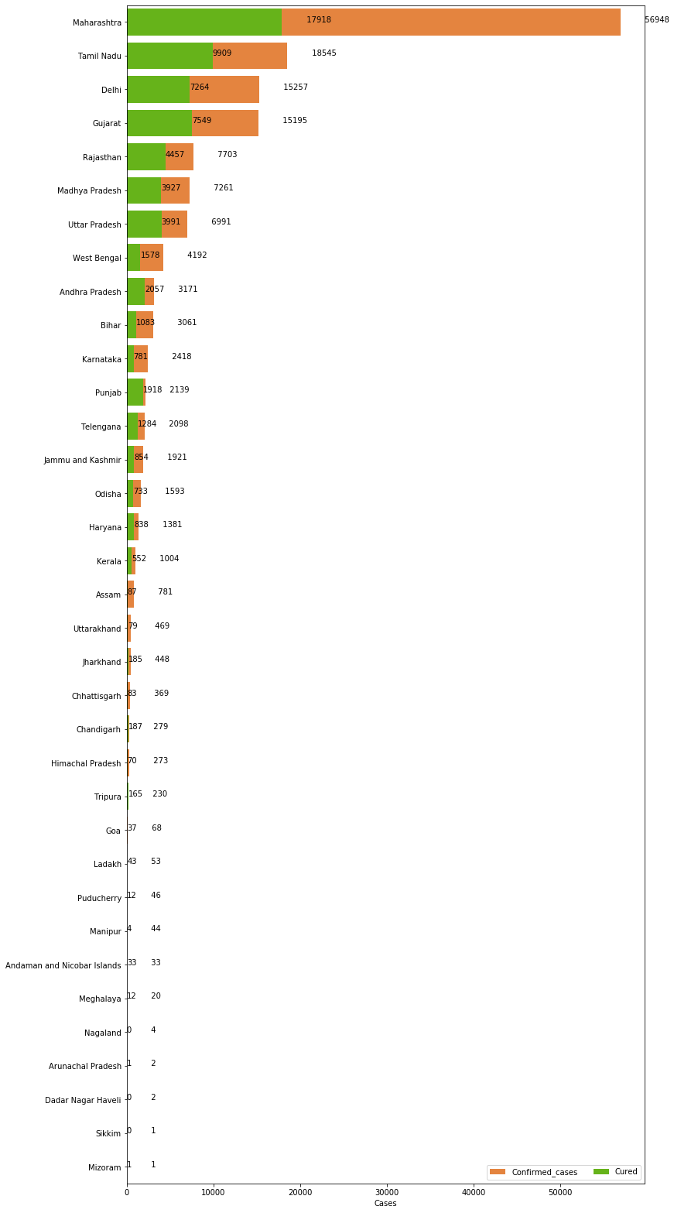

**27:**

f, ax = plt.subplots(figsize=(12, 28))

data = state_df[['State/UnionTerritory','Confirmed','Cured','Deaths']]

data.sort_values('Confirmed',ascending=False,inplace=True)

sns.set_color_codes("pastel")

sns.barplot(x="Confirmed", y="State/UnionTerritory", data=data,label="Total", color="red")

sns.set_color_codes("muted")

sns.barplot(x="Cured", y="State/UnionTerritory", data=data, label="Cured", color="green")

ax.legend(ncol=5, loc="lower right", frameon=True)

ax.set(ylabel="",xlabel="Cases")

total = total_cases_india

i = 0

for p in ax.patches:

percentage = '{:.1f}%'.format(100 * p.get_width()/total)

x = p.get_x() + p.get_width() + 3

y = p.get_y() + p.get_height()/2

if i <= len(States):

ax.annotate(" "*10 + str(percentage), (x, y))

else:

ax.annotate(percentage, (x, y))

i += 1

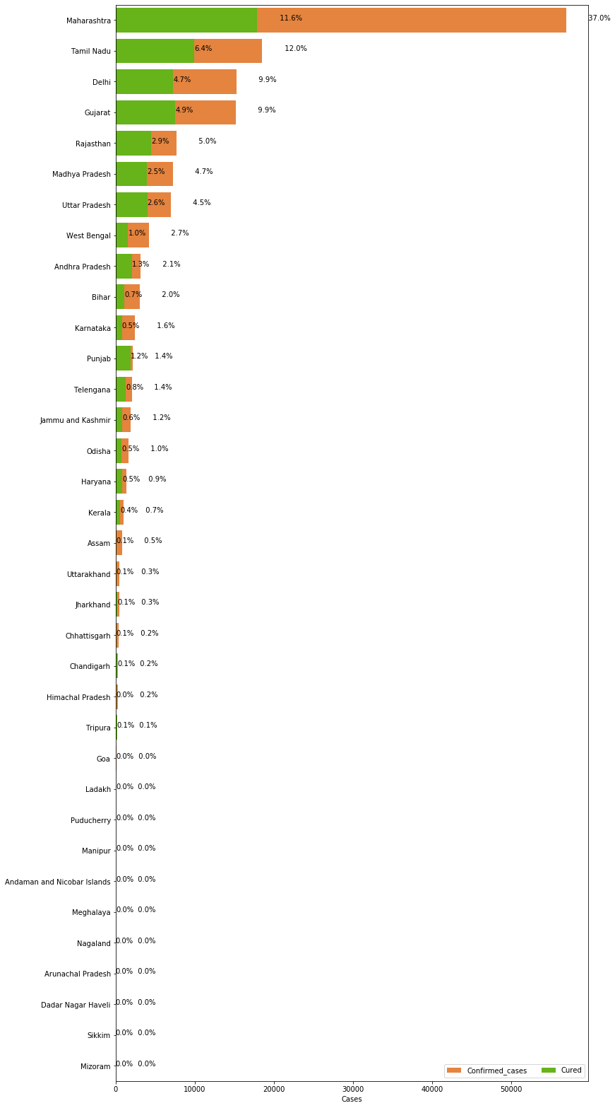**Output:**

**Overall Covid-19 Status in India**

**28:**

* A pie plot is a proportional representation of the numerical data in column. T his function wraps matplotlib.pyplot.**pie()** for the specified column.
* In the above pie chart shows the how many cases are active, recovered from covid19, and how many have died because of covid19 in India.

print("Total infected cases in India: ", total_cases_india)

print("Total cured cases in India: ", cured_cases_india)

print("Total active cases in India: ", active_cases_india)

print("Total death cases in India: ", death_cases_india)

plot_pie(active_cases_india, cured_cases_india, death_cases_india, "India")

**Output:**



**VISUALISING THE SPREADS GEOGRAPHICALLY**

**29:**

* Here, the column named Name of State / UT is renamed to State/UnionTerritory with the help of **rename()** Function so the resultant dataframe will be Rename the specific column value by index in python.

India_coord.rename(columns = {"Name of State / UT" : "State/UnionTerritory"},inplace =

True)

**30:**

set(India_coord['State/UnionTerritory'].values).symmetric_difference(set(state_df['State/UnionTerritory'].values))

**Output:**

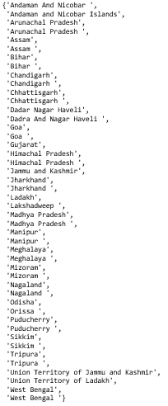

**31:**

* Here ,Python **set()** is used to create a set from iterable. As set does not allow duplicate, set function will retain only unique elements and will remove duplicates. It is one of the way to create set.

India_coord['State/UnionTerritory'] = India_coord['State/UnionTerritory'].str.strip()

state_df['State/UnionTerritory'] = state_df['State/UnionTerritory'].str.strip()

**32:**

set(India_coord['State/UnionTerritory'].values).symmetric_difference(set(state_df['State/UnionTerritory'].values))

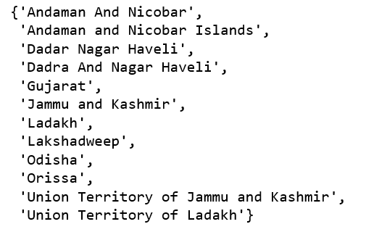**Output:**

**33:**

* Pandas provide a unique method to retrieve rows from a Dataframe. **DataFrame.loc[]** method is a method that takes only index labels and returns row or dataframe if the index label exists in the caller data frame.

India_coord.loc[India_coord.shape[0]] = ['Gujarat','22.2587','71.1924']

India_coord

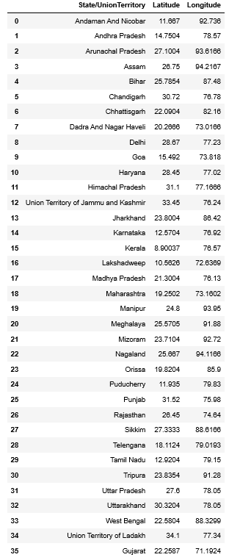**Output:**

**34:**

* Here ,Python **set()** is used to create a set from iterable.As set does not allow duplicate, set function will retain only unique elements and will remove duplicates.It is one of the way to create set.

set(India_coord['State/UnionTerritory'].values).symmetric_difference(set(state_df['State/UnionTerritory'].values))

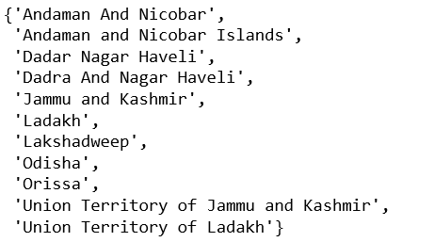**Output:**

**35:**

India_coord['State/UnionTerritory'] = np.where(India_coord['State/UnionTerritory'] ==

"Andaman And Nicobar", "Andaman and Nicobar

Islands", India_coord['State/UnionTerritory'])

India_coord['State/UnionTerritory'] = np.where(India_coord['State/UnionTerritory'] ==

"Union Territory of Jammu and Kashmir",

"Jammu and Kashmir",

India_coord['State/UnionTerritory'])

India_coord['State/UnionTerritory'] = np.where(India_coord['State/UnionTerritory'] ==

"Union Territory of Ladakh","Ladakh",

India_coord['State/UnionTerritory'])

India_coord['State/UnionTerritory'] = np.where(India_coord['State/UnionTerritory'] ==

"Orissa", "Odisha",

India_coord['State/UnionTerritory'])

India_coord['State/UnionTerritory'] = np.where(India_coord['State/UnionTerritory'] ==

"Dadra And Nagar Haveli", "Dadar Nagar Haveli",

India_coord['State/UnionTerritory'])

**36:**

set(India_coord['State/UnionTerritory'].values).symmetric_difference(set(state_df['State/UnionTerritory'].values))

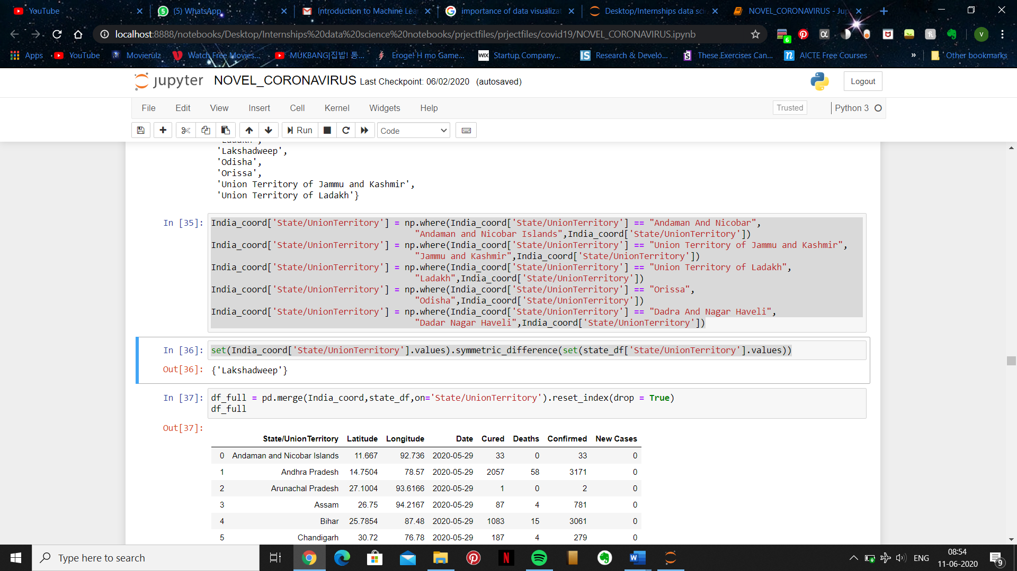**Output:**

**37:**

* **merge()** is a function in the pandas namespace, and it is also available as a DataFrame instance method, with the calling DataFrame being implicitly considered the left object in the join.

df_full = pd.merge(India_coord,state_df,on='State/UnionTerritory').reset_index(drop = True)

df_full

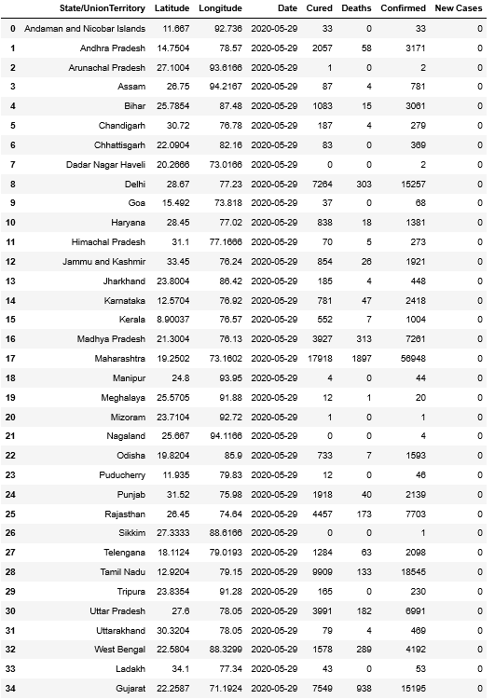**Output:**

**38:**

* In this map, we can see the radius to what extent it has expanded for each state which contains COVID-19 cases. this map is open street map type.
* Here zoom_start () means Initial zoom level for map.
* To point the location we are using CircleMarker() method.

map = folium.Map(location=[20, 70], zoom_start=4,tiles='Stamenterrain')

for lat, lon, value, name in zip(df_full['Latitude'], df_full['Longitude'], df_full['Confirmed'], df_full['State/UnionTerritory']):

folium.CircleMarker([lat, lon], radius=value*0.0015, popup = ('<strong>State</strong>: ' + str(name).capitalize() + '<br>''<strong>Total Cases</strong>: ' + str(value) + '<br>'),color='red',fill_color='red',fill_opacity=0.3 ).add_to(map)

map

**Output:**



**39:**

* folium.Map() function returns a map object(which is an iterator) of the results after applying the given function to each item of a given iterable (list, tuple etc.).
* Here we are using map() which is from folium package to view covid19 cases in all over the world.To point the location we are using CircleMarker() method.

map = folium.Map(location=[20, 70], zoom_start=4,tiles='OpenStreetMap')

for lat, lon, value, name in zip(df_full['Latitude'], df_full['Longitude'], df_full['Confirmed'], df_full['State/UnionTerritory']):

folium.CircleMarker([lat, lon], radius=value*0.0015, popup = ('<strong>State</strong>: ' + str(name).capitalize() + '<br>''<strong>Total Cases</strong>: ' + str(value) + '<br>'),color='red',fill_color='red',fill_opacity=0.3 ).add_to(map)

map

**Output:**



**40:**

* These maps are printed by using a folium package that we have imported and this map is of stamenwatercolor same things we are observing in different types of maps types that are available in the folium package. We are using latitude and longitude present in the df_full data frame and by folium function circularMarker() by using this function we are marking at respective latitude and longitude according to the effect of COVID-19 at that place.

map = folium.Map(location=[20, 70], zoom_start=4,tiles='Stamenwatercolor')

for lat, lon, value, name in zip(df_full['Latitude'], df_full['Longitude'], df_full['Confirmed'], df_full['State/UnionTerritory']):

folium.CircleMarker([lat, lon], radius=value*0.0015, popup = ('<strong>State</strong>: ' + str(name).capitalize() + '<br>''<strong>Total Cases</strong>: ' + str(value) + '<br>'),color='red',fill_color='red',fill_opacity=0.3 ).add_to(map)

map

**Output:**



**Part 6: Data Splitting and Data Modelling**

**Data splitting** is the act of partitioning available data into. two portions, usually for cross-validatory purposes. One. portion of the data is used to develop a predictive model. and the other to evaluate the model's performance.

* Data Splitting is important because splitting data into training and testing sets allows us to cross compare and draw better conclusions from the data and give a clearer picture from the required datasets.

**Data modelling** techniques and methodologies are used to model data in a standard, consistent, predictable manner in order to manage it as a resource. The use of data modelling standards is strongly recommended for all projects requiring a standard means of defining and analysing data within an organization, e.g., using data modelling:

* to assist business analysts, programmers, testers, manual writers, IT package selectors, engineers, managers, related organizations and clients to understand and use an agreed semi-formal model the concepts of the organization and how they relate to one another
* to manage data as a resource
* for the integration of information systems
* for designing databases/data warehouses (aka data repositories)

**Trend of the virus:**

**41:**

* Here we are initialising a new data frame df_daywise_India to observe the daywise trend of the virus in the country.
* The dataframe is initialized to our dataframe df_final_India. by applying the groupby() method. Here we've selected a particular Series group from the original Dataframe group by reference to its column name. And to the groupby object computation is done by calling the aggregate sum() on and then resetting the index on with reset_index() on the object.
* This action adds all the confirmed cases on a particular day for all regions, cured cases on a particular day for all regions, deaths on a particular day for all regions and new cases on a particular day for all regions. and hence gives us a clear daywise trend of the virus in the country.

df_daywise_India = df_final_India.groupby("Date")['Confirmed','Cured','Deaths',"New Cases"].sum().reset_index()

df_daywise_India

**Output:**

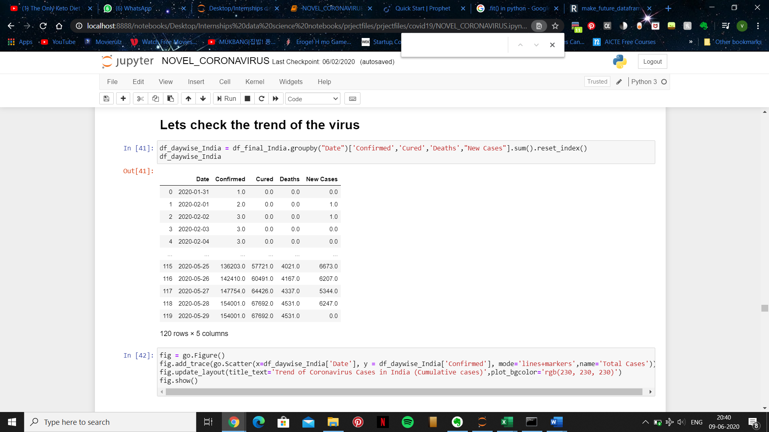

**42:**

* import plotly.graph_objects as go indicates that graphs can be plotted by using the object go. and a new figure is assigned to fig.
* When we want the new figure to the a trace, we use the method add_trace() and by using the method Scatter from plotly_graph, we can plot the graph by using the data from the previous dataframe of df_daywise_India where the x axis is the 'Date' and y axis is 'Confirmed' from the data set.
* Once the x and y axises are defined, the type of plot chosen is line+markers where the plot is marked with pinpoints and then joined with lines. the name of the plot is given as 'Total cases'
* Then the update_layout() method is used to personalize our trace. the title is given as: 'Trend of Coronavirus Cases in India (Cumulative cases)’ and the background color of the plot is given as: 'rgb(230, 230, 230)' which produces a color as shown in the output.

fig = go.Figure()

fig.add_trace(go.Scatter(x=df_daywise_India['Date'], y = df_daywise_India['Confirmed'], mode='lines+markers',name='Total Cases'))

fig.update_layout(title_text='Trend of Coronavirus Cases in India (Cumulative cases)',plot_bgcolor='rgb(230, 230, 230)')

fig.show()

**Output:**

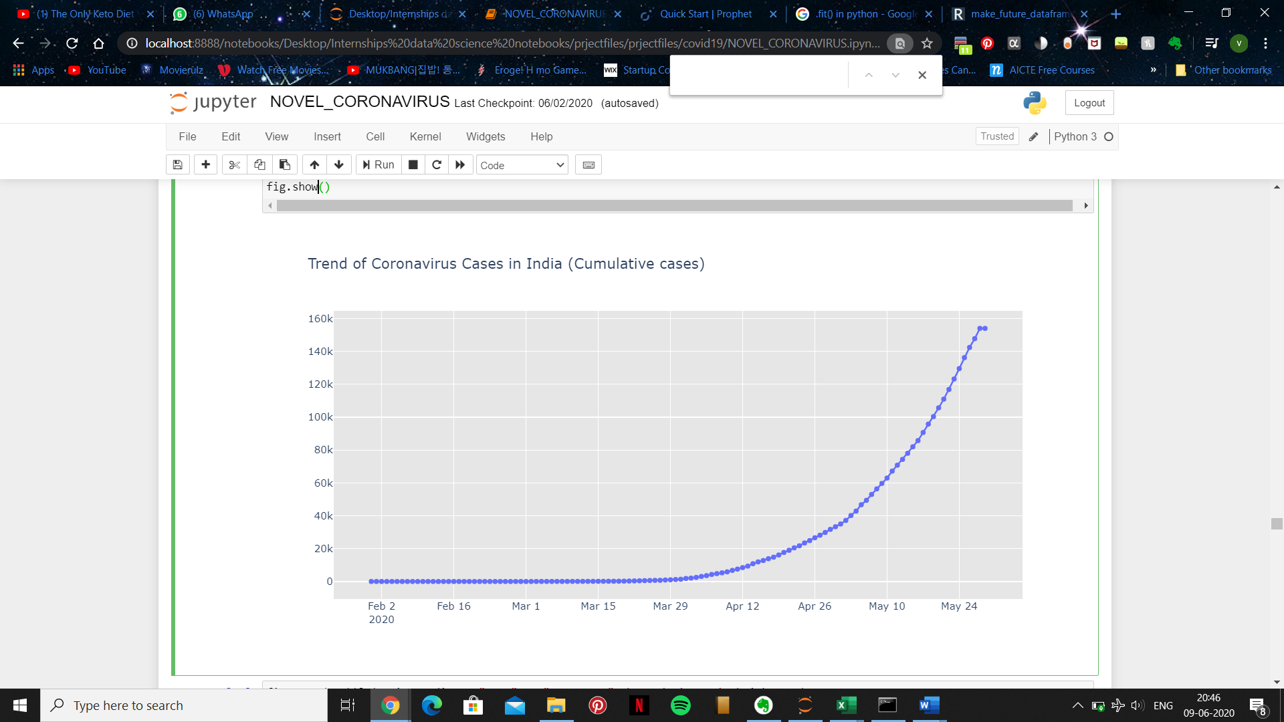

**43:**

* After plotting a line+marker graph, using scatter we now move on to bar graph using the package plotly.express, which is exported and px and using the method bar() from it.
* Here the x axis is 'Date' and y axis is 'New Cases' from the dataset of df_daywise_India. The type of bar graph specified with barmode is group and then we customize the plot using update_layout().

fig = px.bar(df_daywise_India, x="Date", y="New Cases", barmode='group', height=400)

fig.update_layout(title_text='Coronavirus Cases in India on daily basis',plot_bgcolor='rgb(230, 230, 230)')

fig.show()

**Output:**



**44:**

* While the next plot is similar to the previous one in terms that they both are bar graphs, this plot uses a color gradient.
* The data set df_daywise_India is used where the x axis is 'Date', y axis is 'Confirmed' and the gradient color is applied according to the magnitude of the y axis values hence color = 'confirmed' and the gradient position is given as vertical. then after the title of the plot is specified, the gradient is specified with the help of color_discrete_sequence and then our desired color scale is chosen from the provided link. and as the final step the figure is customized.

fig = px.bar(df_daywise_India, x="Date", y="Confirmed", color='Confirmed',

orientation='v', height=600,title='Confirmed Cases in India',

color_discrete_sequence = px.colors.cyclical.IceFire)  
'''Colour Scale for plotly

<https://plot.ly/python/builtin-colorscales/>

'''

fig.update_layout(plot_bgcolor='rgb(230, 230, 230)')

fig.show()

**Output:**

**45:**

* The next cell of code is for that of a simple line graph.
* Here on the x axis 'date' from the data set df_daywise_India is plotted whereas on the y axis, new cases is plotted. the labels for x axis and y axis is given as 'dates' and ' counts' respectively, and after customizing the figure and it's background we have the plot that we need.

fig = px.line(x=df_daywise_India['Date'], y=df_daywise_India['New Cases'], labels = {'x': "Dates",'y': "Counts"})

fig.update_layout( showlegend=False,title_text="Trend of Coronavirus cases")

fig.update_layout(plot_bgcolor='rgb(250, 242, 242)')

fig.show()

**Output:**



**Forecasting Using fbprophet :**

* After finding out the trend of the virus with the help of day to day numbers it is time to move a more accurate analysis by taking into account the yearly, weekly, and daily seasonality, plus holiday effects.
* This can be done best with the help of fbprophet. It implements a procedure for forecasting time series data based on an additive model where non-linear trends are fit with yearly, weekly, and daily seasonality, plus holiday effects.
* It works best with time series that have strong seasonal effects and several seasons of historical data. Prophet is robust to missing data and shifts in the trend, and typically handles outliers well.
* we import fbprophet as Prophet for the ease of use in the program

**46:**

from fbprophet import Prophet

**47:**

* Next important step is to train the data
* From the data frame df_daywise_India the last row is selected with the help of iloc which is integer location based indexing.
* and then .loc which uses label or Boolean and logical based indexing is used to select all the rows where the 'date' column’s value is less than or equal  to 202-05-23 and is assigned to  df_train. here we used the Boolean or logical bases indexing and using the same in the next line we select all the rows of the dataframe where the 'date' had a value greater than 2020-05-23 and assign it to df_test.

df = df_daywise_India.iloc[:-1,]

df_train = df.loc[df['Date']<= "2020-05-23",:]

df_test = df.loc[df['Date'] > "2020-05-23",:]

**48:**

* After assiging values to df_train and df_test, we create new dataframes :
* confirmed_train and confirmed_test which includes the date and the number of confirmed cases.
* death_train and death_test which includes the date and the number of death cases.
* recovered_train and recovered_test which includes the date and the number of recovered cases.

confirmed_train = df_train[['Date','Confirmed']]

confirmed_test = df_test[['Date','Confirmed']]

deaths_train = df_train[['Date','Deaths']]

deaths_test = df_test[['Date','Deaths']]

recovered_train = df_train[['Date','Cured']]

recovered_test = df_test[['Date','Cured']]

**49:**

* And then we print one of the newly formed dataframes for an example

confirmed_train.columns = ['ds','y']

confirmed_train.tail()

**Output:**

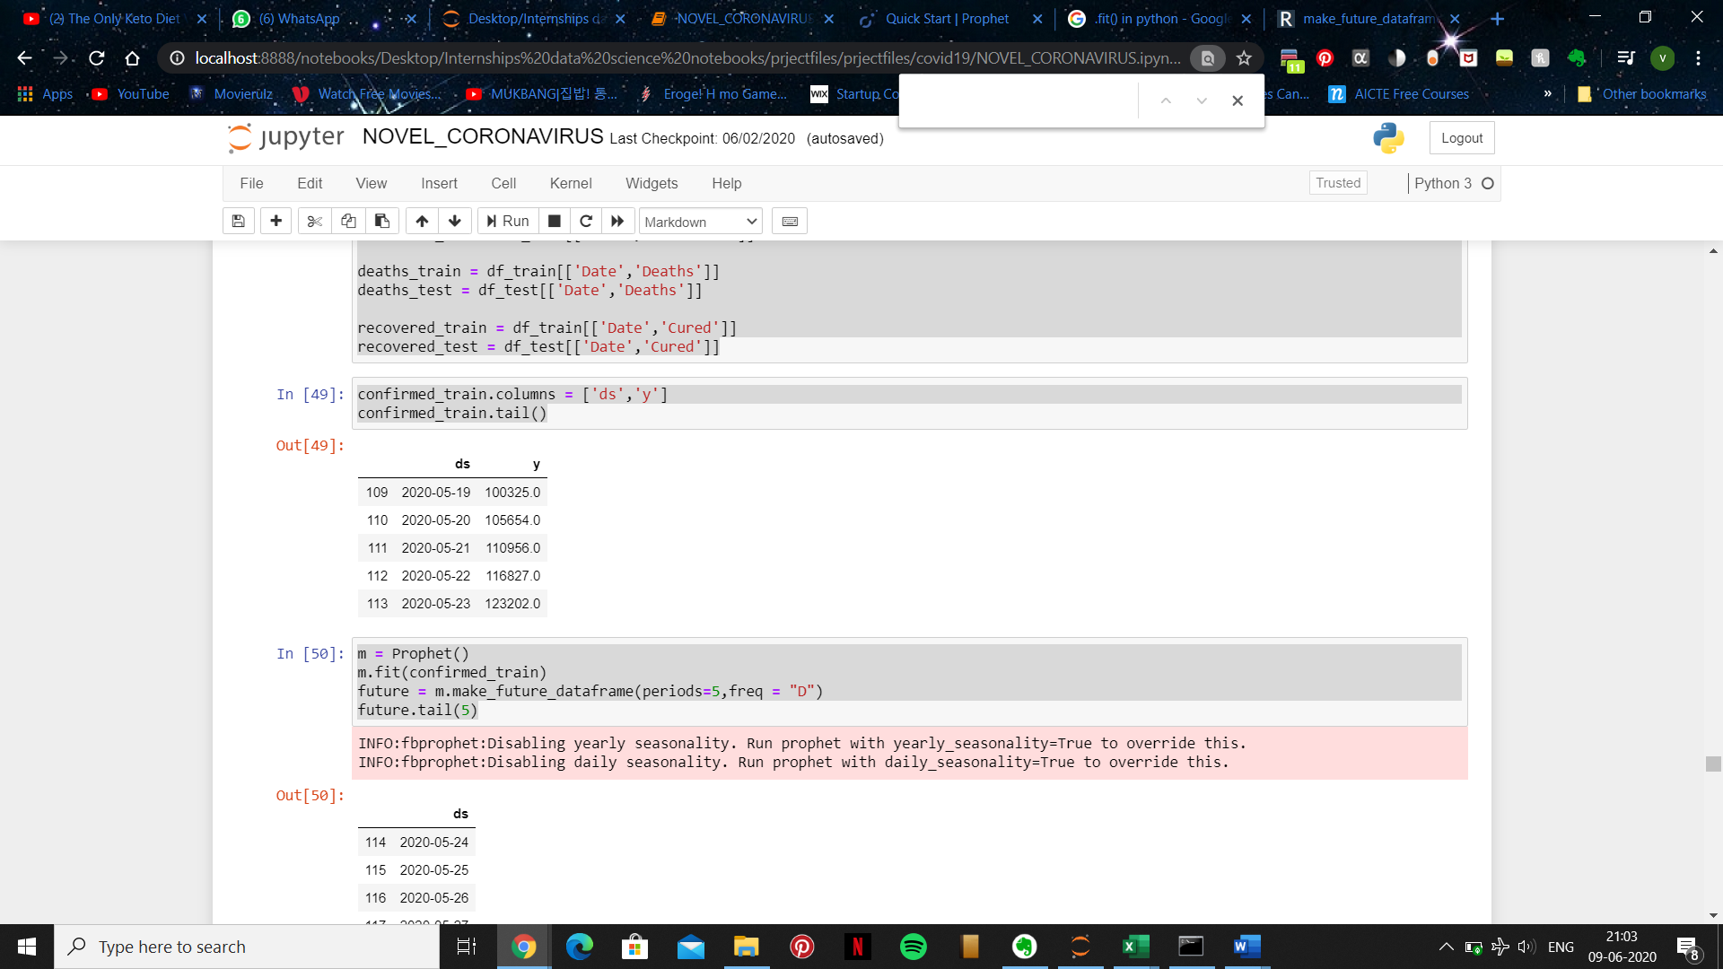

**50:**

* Here by assigning Prophet() to a new object m we can make new predictions.
* After using fit() to fit our confirmed_train dataframe well, we can use make_future_dataframe to make future predictions using the already existing data upto a 5 days.
* The predicted data is as shown as follows.

m = Prophet()

m.fit(confirmed_train)

future = m.make_future_dataframe(periods=5,freq = "D")

future.tail(5)

**Output:**

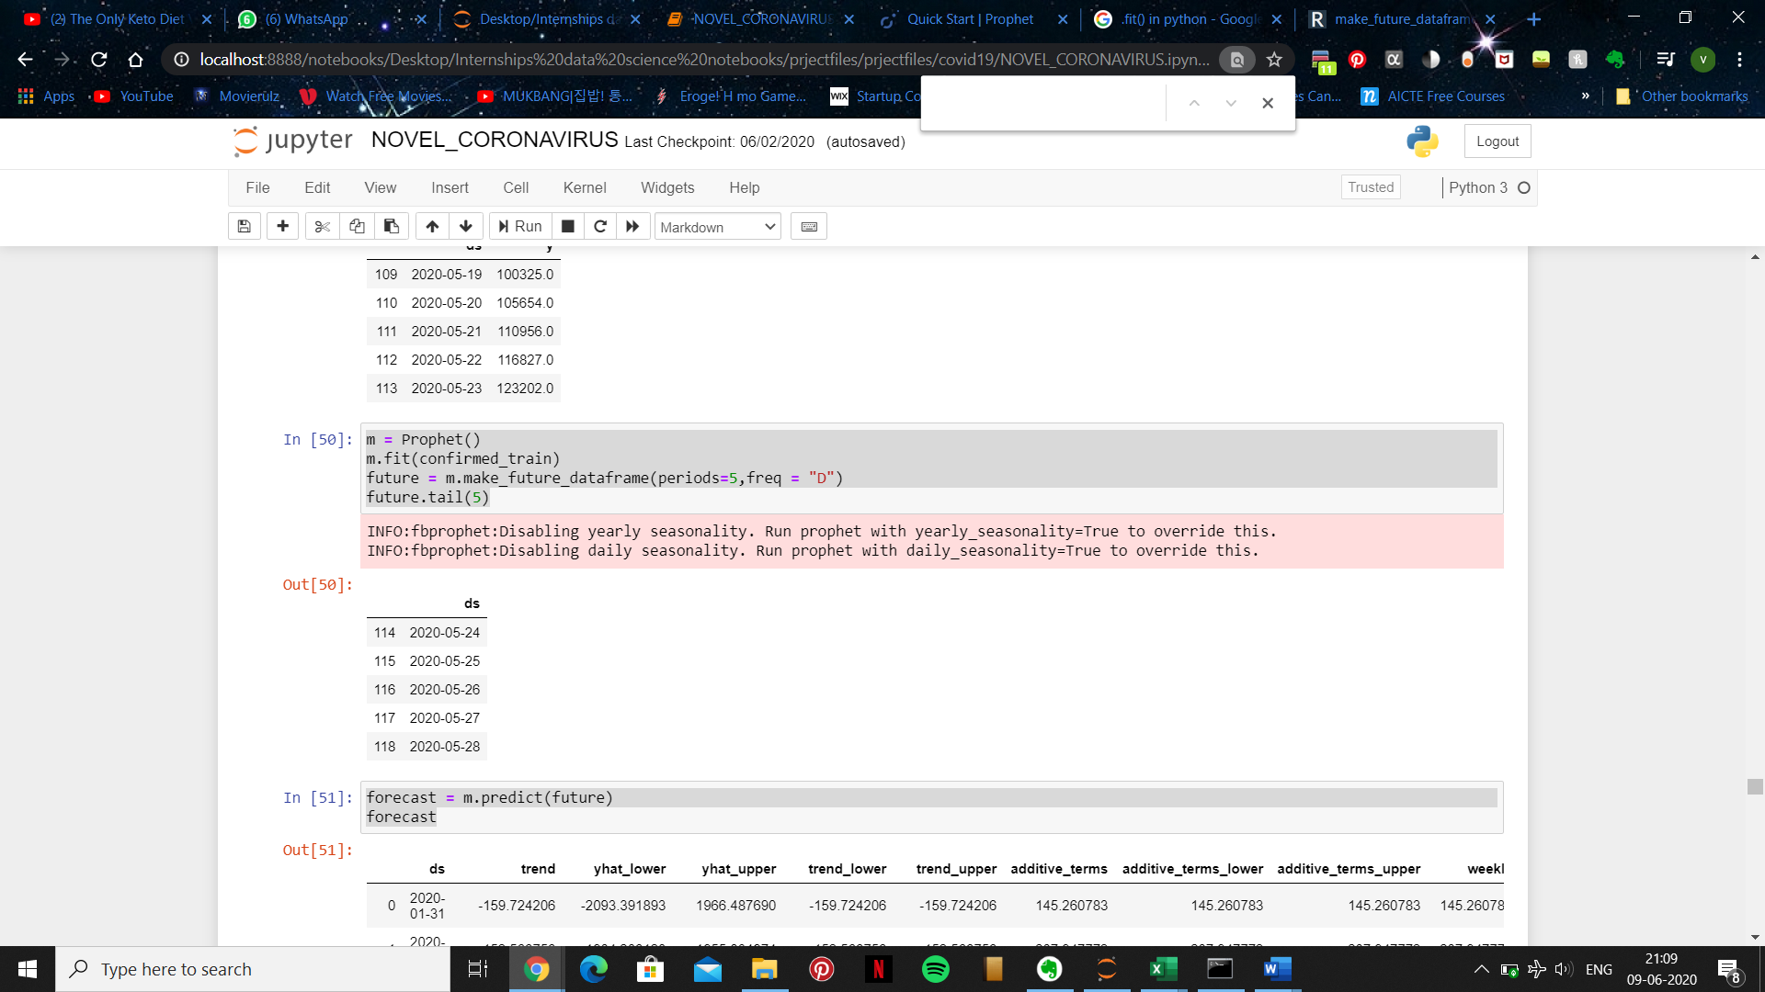

**51:**

* And by using the above lines of code, the complete data set along with our past and future predicted data can be complied into one dataframe and can be displayed as shown.

forecast = m.predict(future)

forecast

**Output:**

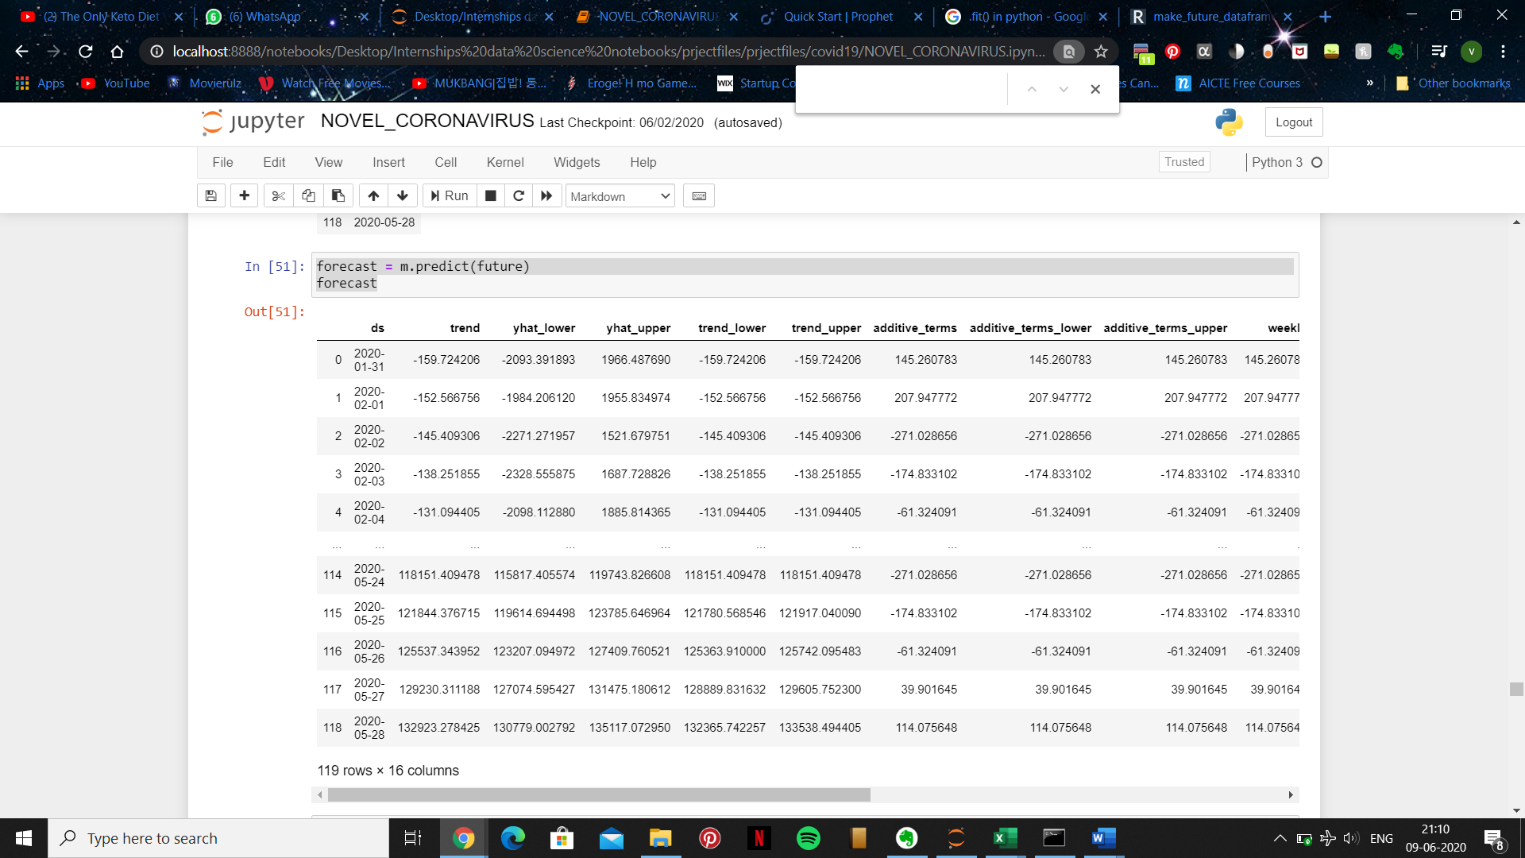

**52:**

* Creating a new dataframe result_df which contains the predicted values with the specified columns and adding a new column named 'Actual' which corresponds to the 'Confirmed' from the confirmed_test dataframe.

result_df = forecast[['ds', 'yhat', 'yhat_lower', 'yhat_upper']].tail(5)

result_df['Actual'] = confirmed_test['Confirmed']

result_df

**Output:**

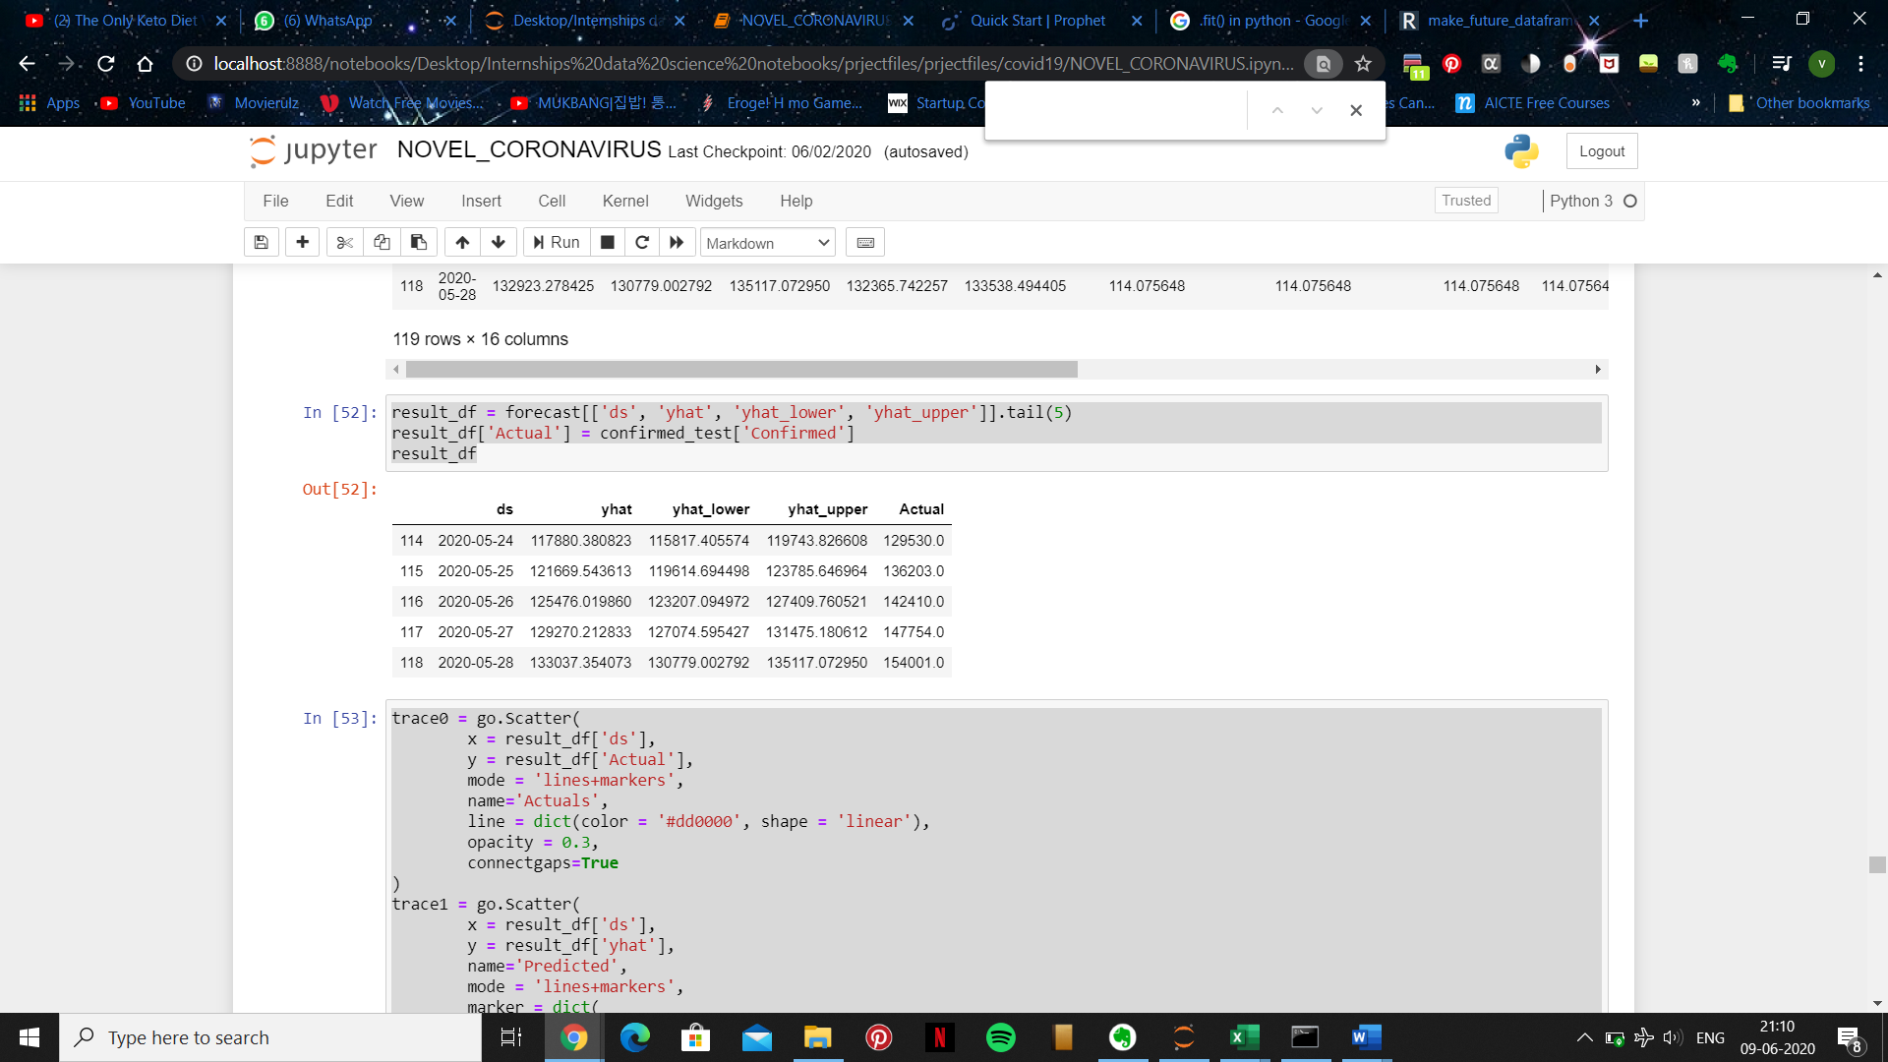

**53:**

* Plotting a graph using the above dataframe with we create a graph which uses both lines and makers.
* The graph consists of two individual parts where the first part is plotted by using ds as the x axis and actual as the y axis from the result_df dataframe and the second using ds as the x axis and yhat as the y axis from the same dataframe.
* Naming the y axis of the actual graph "Result for Prophet(Total Cases)" and customizing it to our needs we have the desired output.

trace0 = go.Scatter(

        x = result_df['ds'],

        y = result_df['Actual'],

        mode = 'lines+markers',

        name='Actuals',

        line = dict(color = '#dd0000', shape = 'linear'),

        opacity = 0.3,

        connectgaps=True

)

trace1 = go.Scatter(

        x = result_df['ds'],

        y = result_df['yhat'],

        name='Predicted',

        mode = 'lines+markers',

        marker = dict(

            size = 10,

            color = '#44dd00'),

        opacity = 0.3

)

data = [trace0, trace1]

layout = go.Layout(

    yaxis=dict(

        title="Results for Prophet (Total Cases)"

    )

)

fig = go.Figure(data=data, layout=layout)

fig.show()

**Output:**



After which we repeat the same process for the remaining data sets : recovered_test, recovered_train and death_test and death_train

**54:**

* Our dataframe.

recovered_train.columns = ['ds','y']

recovered_train.tail()

**Output:**

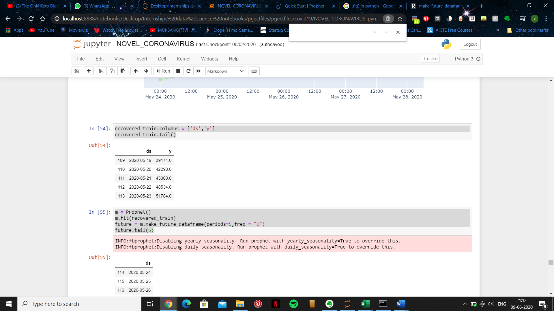

**55**:

* Predicting future data from existing set.

m = Prophet()

m.fit(recovered_train)

future = m.make_future_dataframe(periods=5,freq = "D")

future.tail(5)

**Output:**

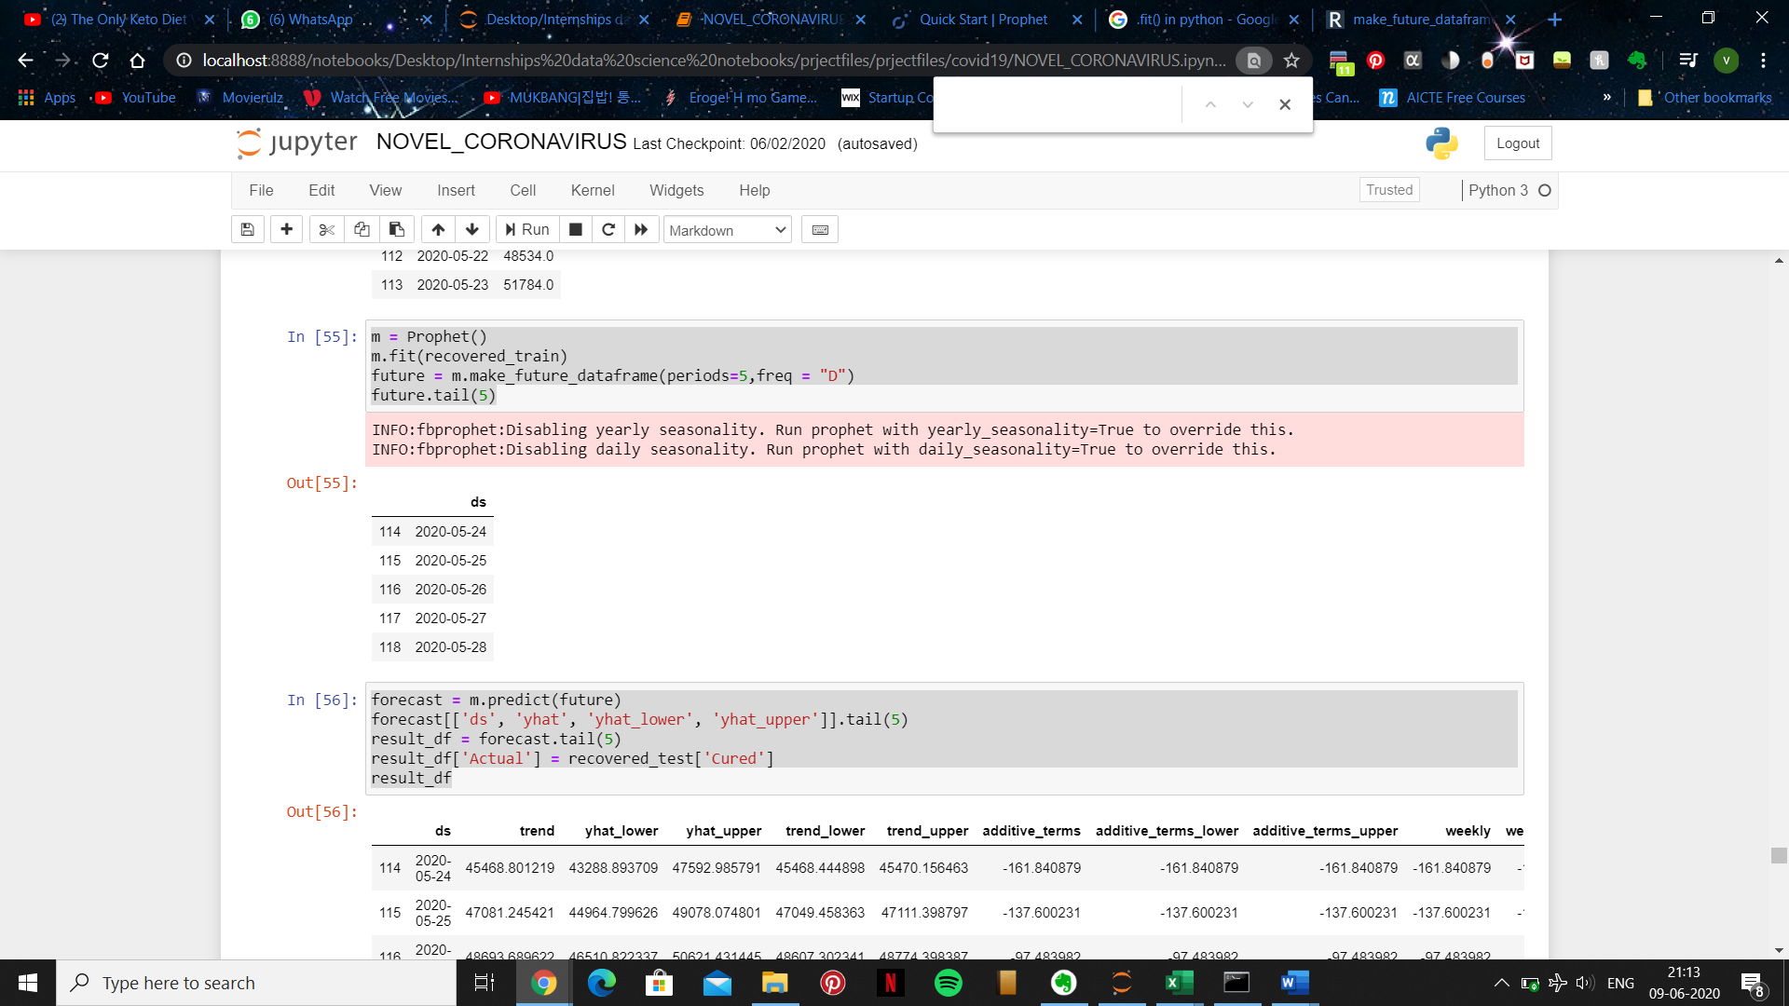

**56:**

* Our new dataframe which includes the existing data and the predicted data.

forecast = m.predict(future)

forecast[['ds', 'yhat', 'yhat_lower', 'yhat_upper']].tail(5)

result_df = forecast.tail(5)

result_df['Actual'] = recovered_test['Cured']

result_df

**Output:**

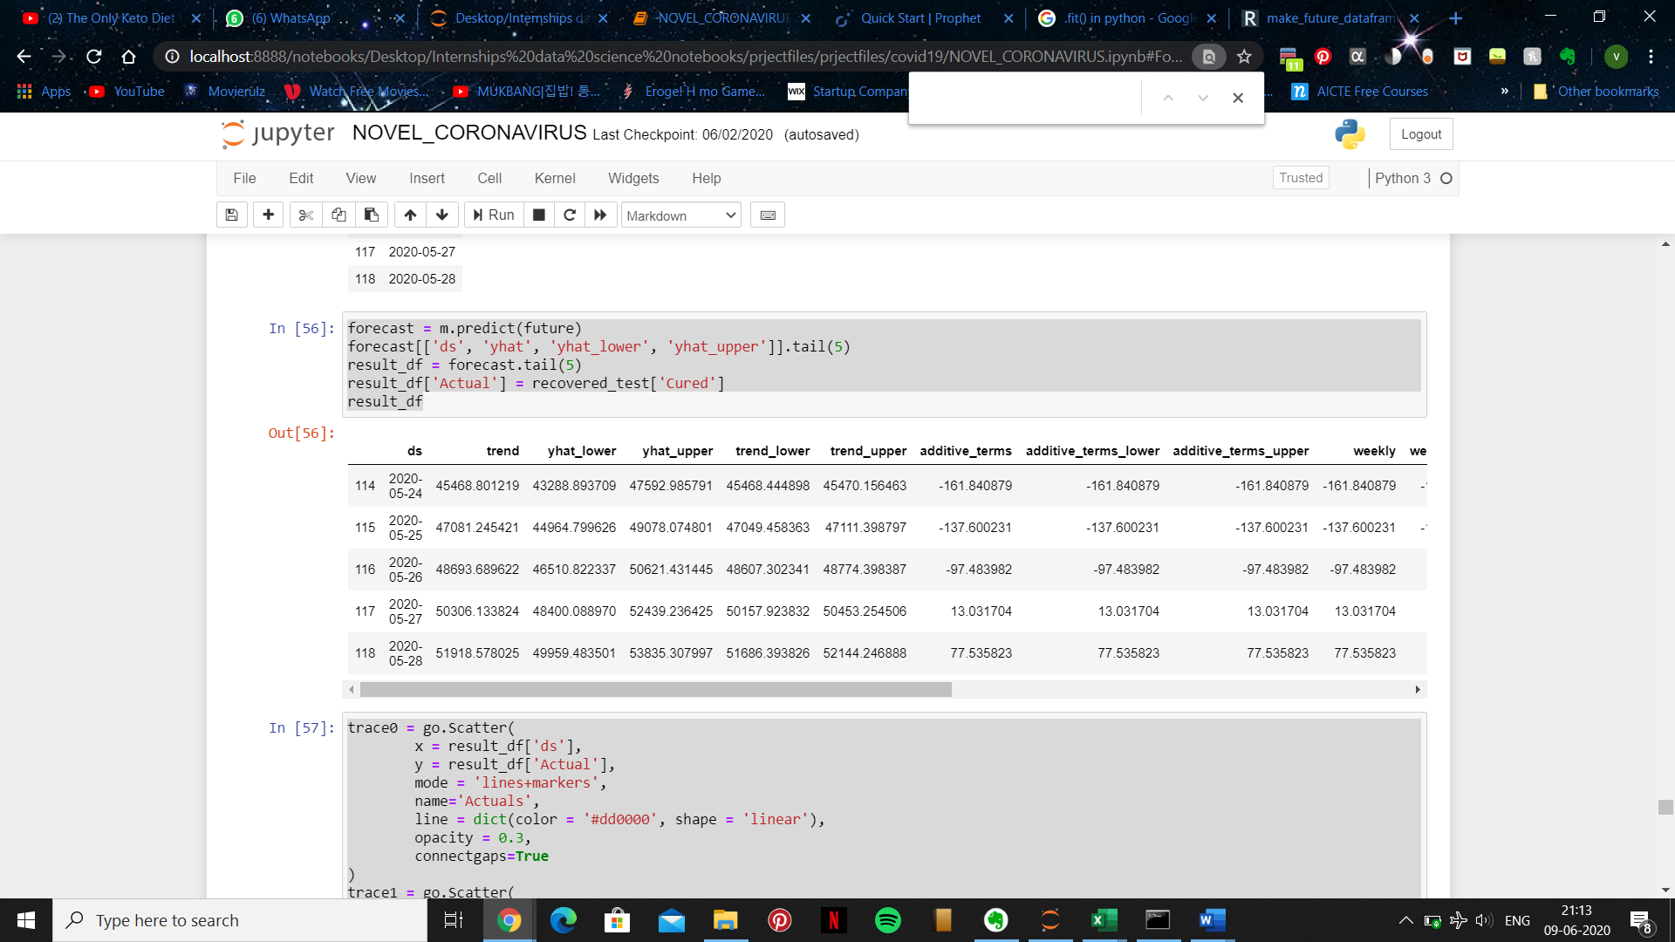

**57:**

* Plotting a graph to show the outputs and differences between our existing and predicted dataframe.

trace0 = go.Scatter(

        x = result_df['ds'],

        y = result_df['Actual'],

        mode = 'lines+markers',

        name='Actuals',

        line = dict(color = '#dd0000', shape = 'linear'),

        opacity = 0.3,

        connectgaps=True

)

trace1 = go.Scatter(

        x = result_df['ds'],

        y = result_df['yhat'],

        name='Predicted',

        mode = 'lines+markers',

        marker = dict(

            size = 10,

            color = '#44dd00'),

        opacity = 0.3

)

data = [trace0, trace1]

layout = go.Layout(

    yaxis=dict(

        title="Results for Prophet (Recovered)"

    )

)

fig = go.Figure(data=data, layout=layout)

fig.show()

**Output:**



**58:**

* Our dataframe.

deaths_train.columns = ['ds','y']

deaths_train.tail()

**Output:**

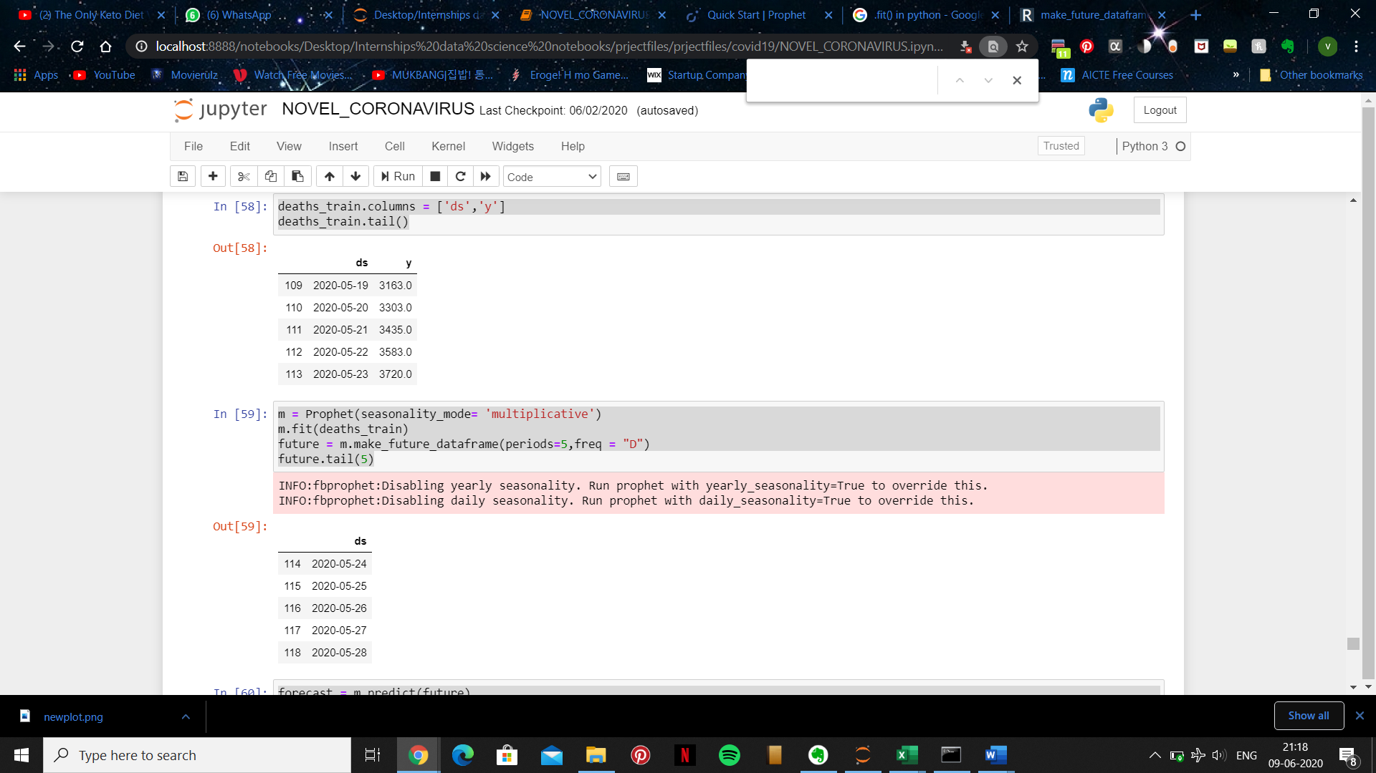

**59:**

* Predicting future data from existing set.

m = Prophet(seasonality_mode= 'multiplicative')

m.fit(deaths_train)

future = m.make_future_dataframe(periods=5,freq = "D")

future.tail(5)

**Output:**

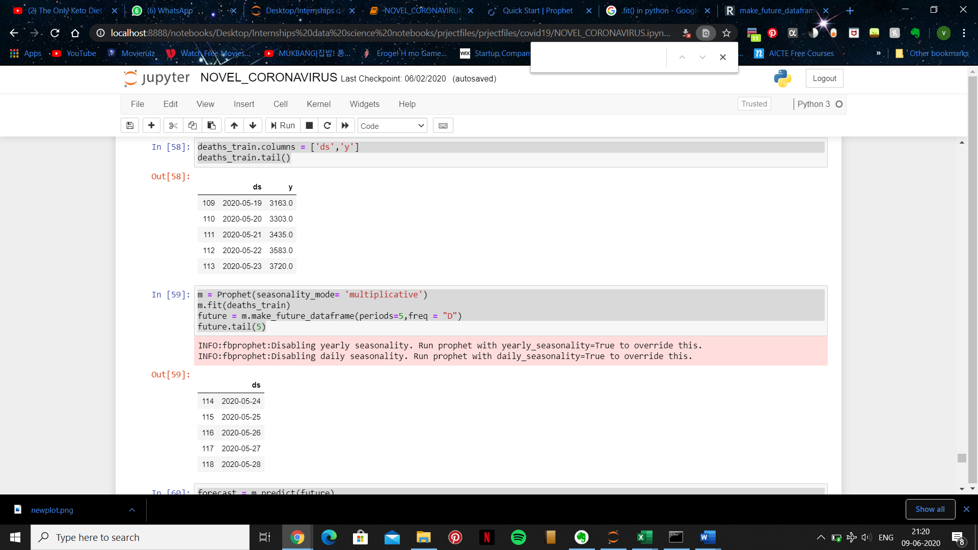

**60:**

* Our new dataframe which includes the existing data and the predicted data.

forecast = m.predict(future)

forecast[['ds', 'yhat', 'yhat_lower', 'yhat_upper']].tail(5)

result_df = forecast.tail(5)

result_df['Actual'] = deaths_test['Deaths']

result_df

**Output:**

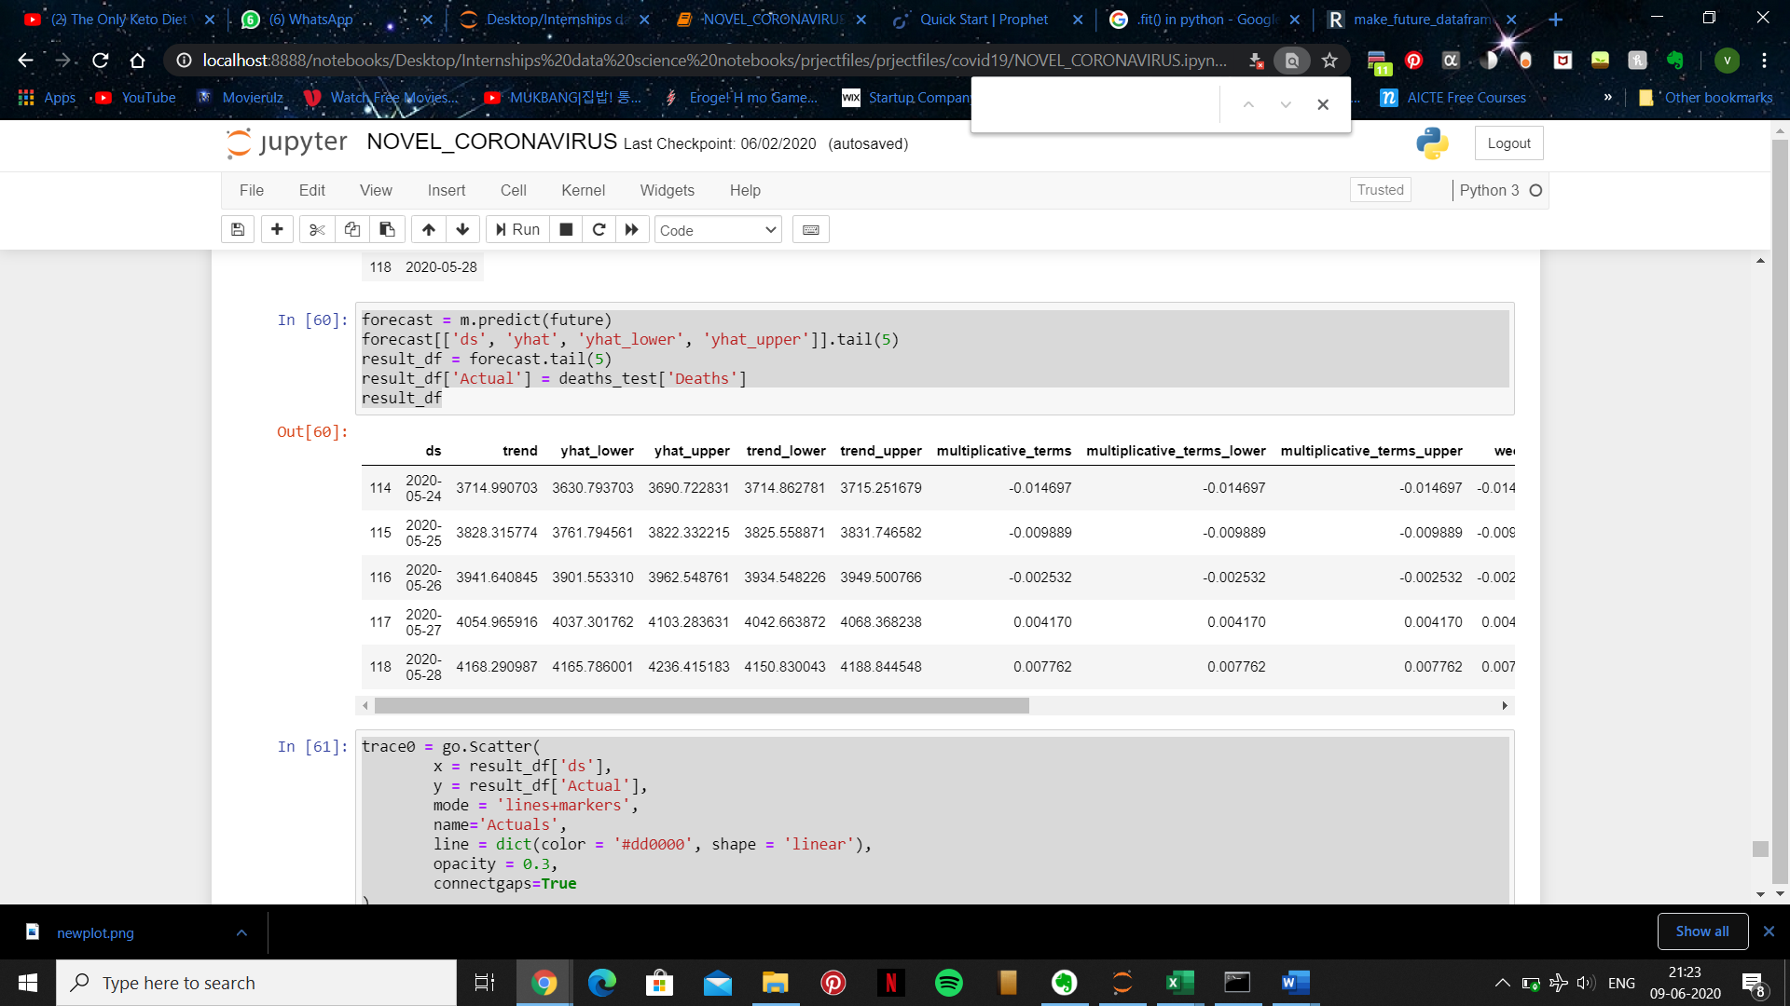

**61:**

* Plotting a graph to show the outputs and differences between our existing and predicted dataframe.

trace0 = go.Scatter(

        x = result_df['ds'],

        y = result_df['Actual'],

        mode = 'lines+markers',

        name='Actuals',

        line = dict(color = '#dd0000', shape = 'linear'),

        opacity = 0.3,

        connectgaps=True

)

trace1 = go.Scatter(

        x = result_df['ds'],

        y = result_df['yhat'],

        name='Predicted',

        mode = 'lines+markers',

        marker = dict(

            size = 10,

            color = '#44dd00'),

        opacity = 0.3

)

data = [trace0, trace1]

layout = go.Layout(

    yaxis=dict(

        title="Results for Prophet (Death)"

    )

)

fig = go.Figure(data=data, layout=layout)

fig.show()

**Output:**



**Part 7: Conclusion**

This study presented a comprehensive analysis of the COVID-19 outbreak situation in India. The cases are rising very fast and they need aggressive control strategies from the Administrative unit of India. The outbreak spreads are largely influenced by each country’s policy and social responsibility. The project has shown the importance of information dissemination that can help in improving response time, and help planning in advance to help reduce risk. The aspects covered up in this study are related to presenting the growth trends of infected cases in India and predictions for the number of deaths, cured, total cases in the country. We also made day wise analysis and the current study implemented various techniques to present the analysis of the data through visualization.